**Object Oriented Programming**

_________

Semester 4th

Name: Muhammad Hamza Javed

Roll Number: 16194

Department of Computer Science

IQRA University, Karachi

**List of Experiments**

|  |  |  |  |  |
| --- | --- | --- | --- | --- |
| **Lab No** | **Topics** | **Mapping** | | **Remarks** |
| **PLO 5**  **(5)** | **PLO 9**  **(5)** |
|  | Introduction to Java |  |  |  |
|  | Java Programming Elements |  |  |  |
|  | Introducing Classes, Objects and Strings in java |  |  |  |
|  | Overloading and Access Control |  |  |  |
|  | Java Control Statement, Operators& Arrays |  |  |  |
|  | Inheritance and Polymorphism in Java |  |  |  |
|  | Use of abstract and final |  |  |  |
|  | Packages & Interfaces |  |  |  |
|  | Introducing JavaFx |  |  |  |
|  | Exploring JavaFx – Java GUI |  |  |  |
|  | Exception Handling |  |  |  |
| Total Marks Obtained 110 | |  |  |  |

***Overall Score: _________ out of 25 Examined by****:* ***Sidra Rehman***

***Overall Formula= (Obtained Score / Total Score)* x *25******(Name and Signature of Concerned)***

**Object Oriented Programming-LAB (3+1)**

### *Instructor: Sidra Rehman*

**Prerequisites:**Computer Programming

**Course Description:**

This course is second programming course for the students who have already taken programming fundamentals / Computer Programming. The course aims to introduce the concepts of object-oriented programming to students with a background in the procedural programming paradigm. The course begins with a brief review of console input/output with emphasis on structured data types and array processing. It then moves on to introduce the object-oriented programming paradigm, focusing on the definition and use of classes along with the fundamentals of object-oriented design including encapsulation and information-hiding; separation of behavior and implementation; classes, subclasses, inheritance; polymorphism; exception handling, visual programming using swing API and event handling.

**Course Contents:**

Evolution of Object Oriented Programming (OOP), Object Oriented concepts and principles, problem solving in Object Oriented paradigm, OOP design process, classes, functions/methods, objects and encapsulation; constructors and destructors, operator and function/method overloading, association, aggregation, composition, generalization, inheritance and its types, derived classes, function/method overriding, abstract and concrete classes, abstract functions, polymorphism, exception handling, Input/output Streams, Swing API and event handling.

**Learning Outcomes:**

|  |  |  |  |
| --- | --- | --- | --- |
| **Mapping of CLOs and PLOs** | | | |
| **Sr. No.** | **Course Learning Outcomes (CLOs)** | **Program Learning Outcomes (PLOs)** | **Bloom’s Taxonomy** |
| CLO_1 | Be able to demonstrate the concepts of object-oriented programming principles i.e. encapsulation, abstraction, inheritance and polymorphism. | PLO_5 | C3 |
| CLO_2 | Be able to use event handling model to develop event-driven programs that respond to user events. | PLO_5 | C3 |
| CLO_3 | Be able to create object oriented solutions for software systems involving fundamental object oriented concepts. | PLO_5,9 | C3,A2 |

|  |  |  |  |
| --- | --- | --- | --- |
| **Assessment tools** | **CLO_1** | **CLO_2** | **CLO_3** |
| Lab Performance/Manual | 25% | 25% | 50% |
| Final Examination | 25% | 25% | 50% |

|  |  |
| --- | --- |
| ***Overall Grading Policy*** | |
| **Assessment Items** | **Percentage** |
| Lab Performance/ Lab Manual | 50% |
| Final Examination | 50% |

**Recommended Book:**

Java How to Program 10th Edition, by Paul Deitel and Harvey Deitel.

**Reference Book:**

Ivor Horton's Beginning Java: Java 7 Edition by Horton, Ivor published by John Wiley & Sons (2011)

**Administrative Instructions:**

* According to institute policy, 75% attendance is *mandatory* to appear in the final examination but 100% will be expected. Approved leaves will not be considered towards attendance.
* Every student should bring manual and notebook in each lab.
* Every student is expected to be in lab before schedule starting time.
* In any case there will be no rescheduling and makeup of labs.

**Lab-01**

**Introduction to Java**

## Objectives:

Getting familiar with the Java development kit (JDK). Running your first Java program using CMD and an IDE.

**What is JDK?**

It's the full featured Software Development Kit for Java, including JRE, and the compilers and tools (like Java Debugger) to create and compile programs. JRE is required to run Java programs while JDK is required when you have to do some Java programming.

**Installing JDK for Windows**

1. Download the JDK from Oracle’s website. Choose the right JDK depending upon your system’s specifications.

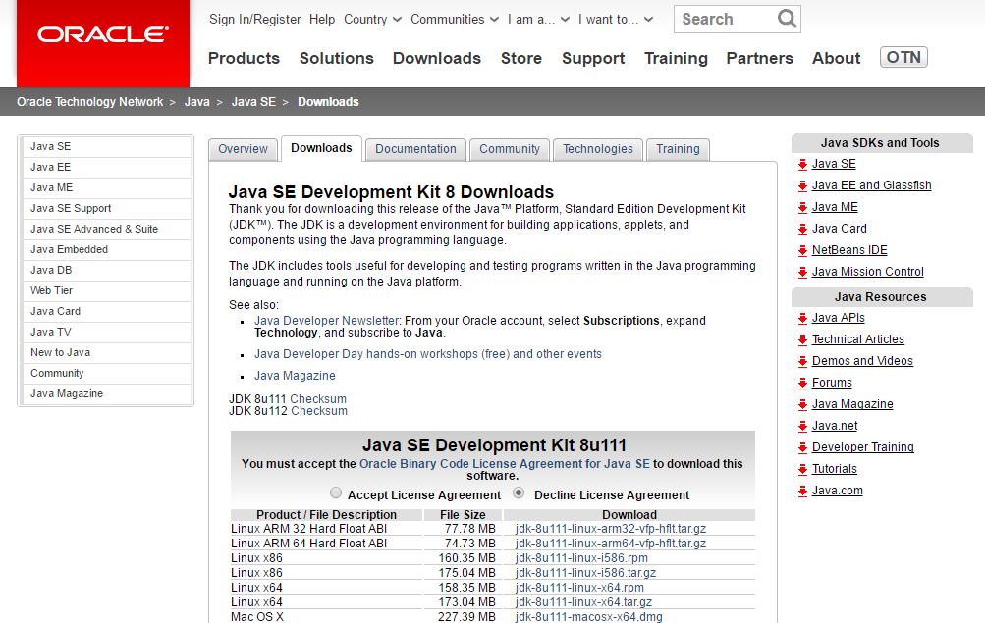

**Figure 1.1: Download the JDK from Oracle’s website**

1. Run the .exe file on your System and follow the steps as given by the installer.

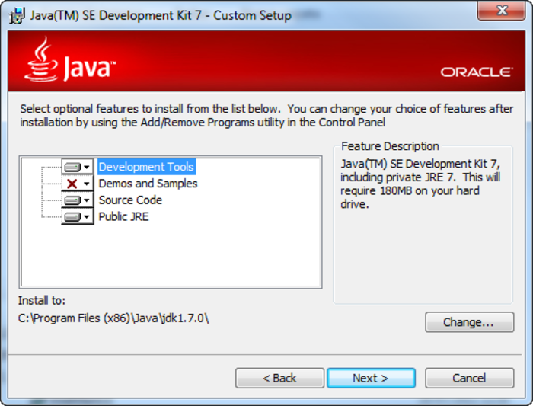

**Figure 1.2 Installing JDK**

1. Note down the location where j2se has been installed. Java Platform is also called as J2SE (Java 2 Platform Standard Edition)
2. Following screen will appear after successful installation.

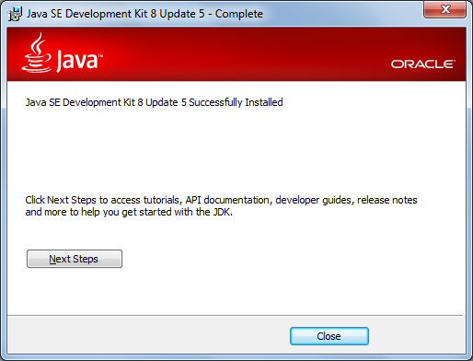

**Figure 1.3: Successful installation**

1. Post installation, you will need to set some environment variables in windows.
2. The path is required to be set for using tools such as javac, java etc.If you are saving the java source file inside the jdk/bin directory, path is not required to be set because all the tools will be available in the current directory. But If you are having your java file outside the jdk/bin folder, it is necessary to set path of JDK.

**Setting Java Path**

There are 2 ways to set java path:

1. temporary
2. permanent
3. **How to set Temporary Path of JDK in Windows**

To set the temporary path of JDK, you need to follow following steps:

* Open command prompt
* Copy the path of jdk/bin directory
* Design in command prompt: set path=copied_path

For Example:

set path=C:\Program Files\Java\jdk1.6.0_23\bin

Let's see it in the figure given below:

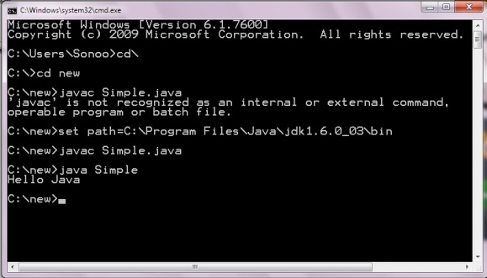

**Figure 1.4: Command Prompt**

1. **How to set Permanent Path of JDK in Windows**

For setting the permanent path of JDK, you need to follow these steps:

* Go to MyComputer properties -> advanced tab -> environment variables -> new tab of user variable -> Design path in variable name -> Design path of bin folder in variable value -> ok -> ok -> ok

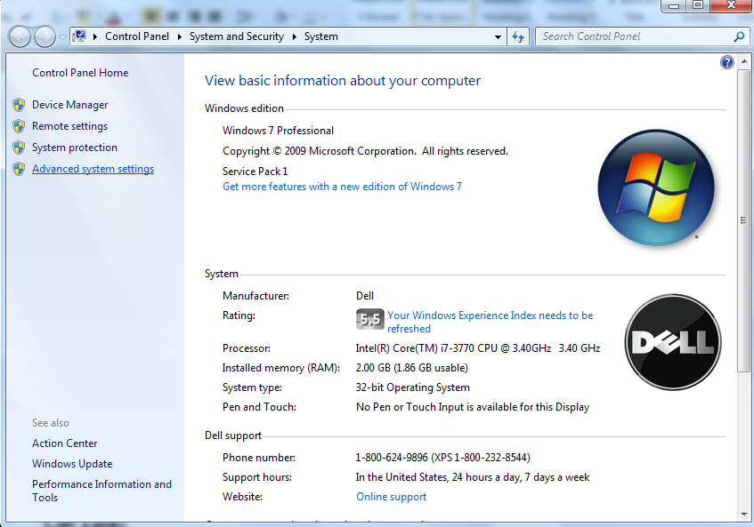

**Figure 1.5: Advance System Settings - Windows**

* Click on environment variables

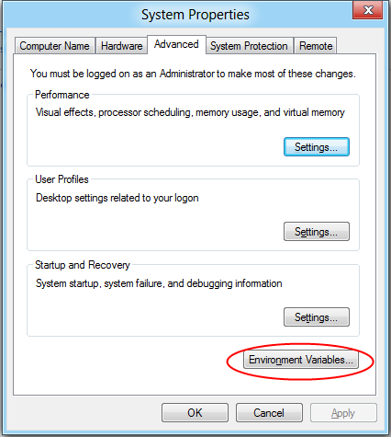

**Figure 1.6: Set Environment Variables**

* Select Path variable and click on Edit button.

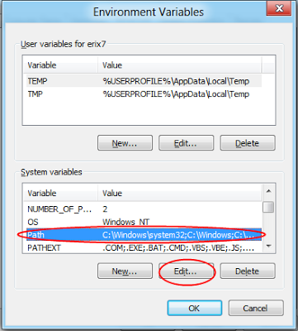

**Figure 1.7: Set Path Variable**

* Copy the path of the bin folder of the JDK and paste it in the variable value field of the path variable. So add ";C:\Program Files\Java\jdk1.7.0_02\bin" in the path string.

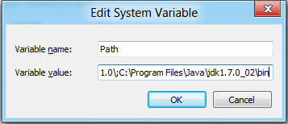

**Figure 1.8: Edit System Variable**

* Click OK... to finish.
* Now your permanent path is set. You can now execute any program of java from any drive.

**Note:**

The PATH environment variable is a series of directories separated by semicolons (;) and is not case-sensitive. Microsoft Windows looks for programs in the PATH directories in order, from left to right.

The new path takes effect in each new command window you open after setting the PATH variable.

**What is an IDE?**

An integrated development environment (IDE) is a software application that provides comprehensive facilities to computer programmers for software development. An IDE may consist of a source code editor; build automation tools, compiler and a debugger.

There are different IDE’s used for Java development including NetBeans and Eclipse.

Before starting to develop the complex programs, you need an IDE. In this workbook we will be using Eclipse IDE for code writing, compilation and execution.

**Install Eclipse IDE**

Download Eclipse form its official website and install it on your system by following the instruction provided by the installer.



**Figure 1.9: Download Eclipse IDE**

After installation, open eclipse. You will see the welcome screen.

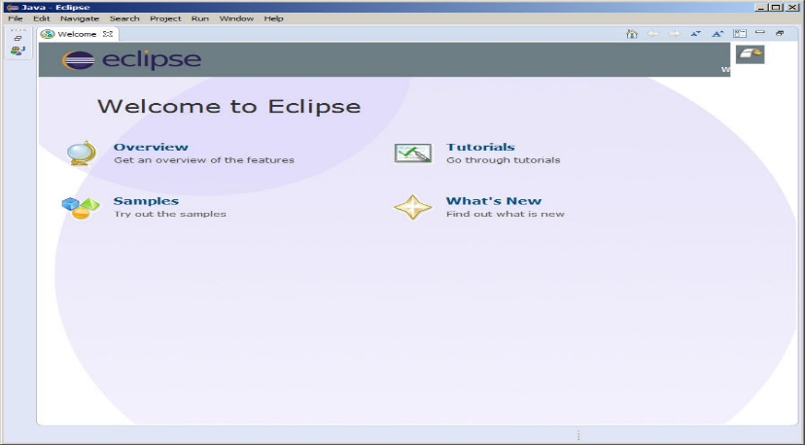

**Figure 1.10: Welcome Screen of Eclipse**

**Design a simple program in java, compile and run it using IDE.**

* Create new project in eclipse. Click on file menu, select Project, then select Java Project and click Next. You will see the following screen. Give your project a name and click Finish.

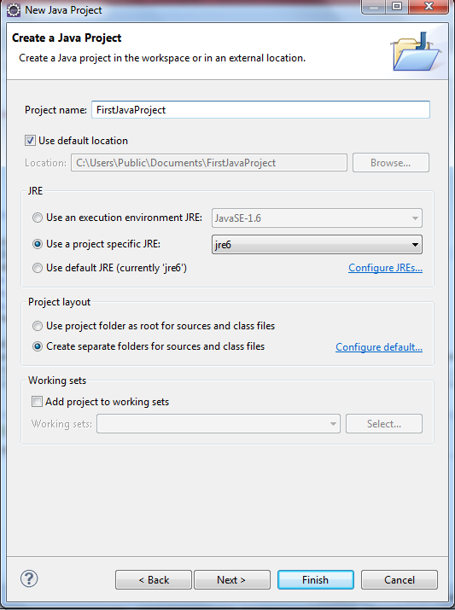

**Figure 1.11: Creating new project in Eclipse**

* Now right click on your project available in project explorer and create new class.

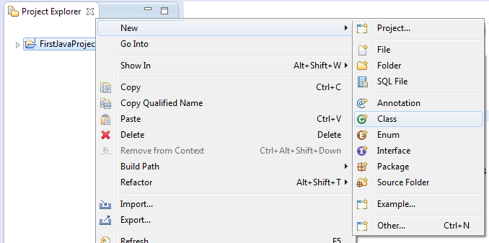

**Figure 1.12: Add new Class**

* A window similar to one shown below will appear. Enter the class name and check the checkbox for public static void main (String[] args). Click finish.

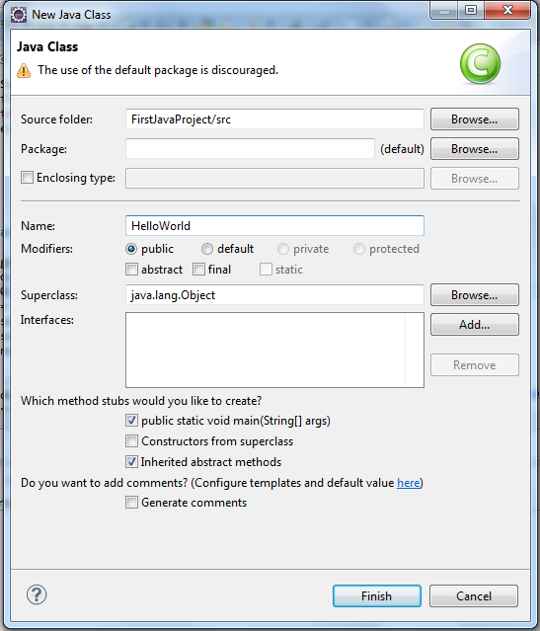

**Figure 1.13: Creating new Class**

* A java file will open with some added code. Just add the following line inside the main() method.System.out.println("Hello World!!");

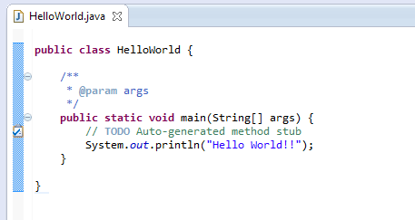

**Figure 1.14: Adding Java Code**

* Save the file.
* Now compile and execute this code. In Eclipse compilation and Execution performs by clicking the button highlighted in the image below.

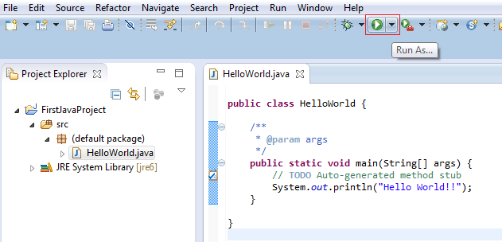

**Figure 1.15: compile& Execute**

* The output of this code will be generated in the console window present below.

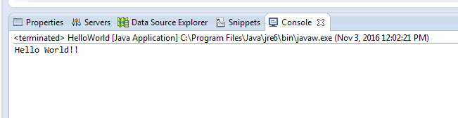

**Figure 1.16: Console Output**

**Lab Task:**

**1. Design a simple program in java, compile and run it using cmd.**

**2. Design a java program to print your bio data using java using IDE**

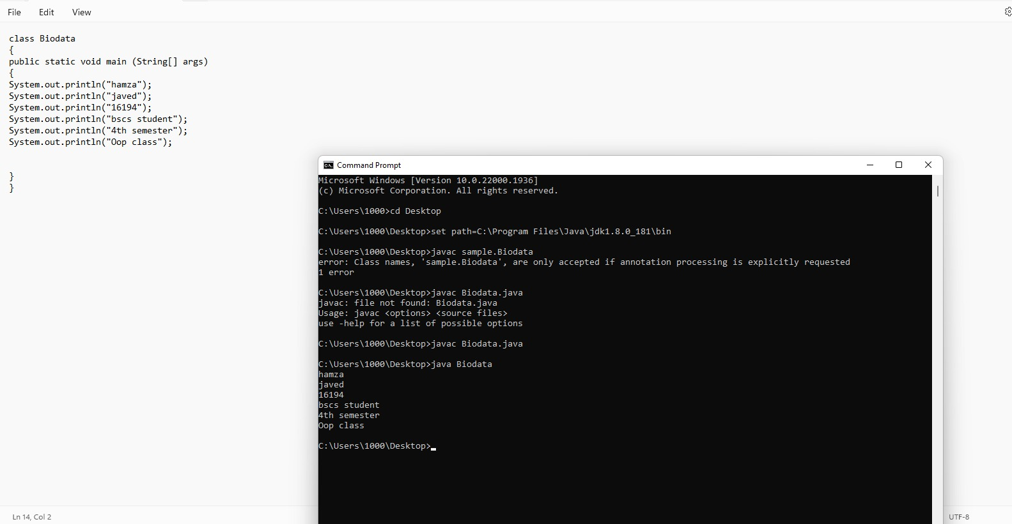

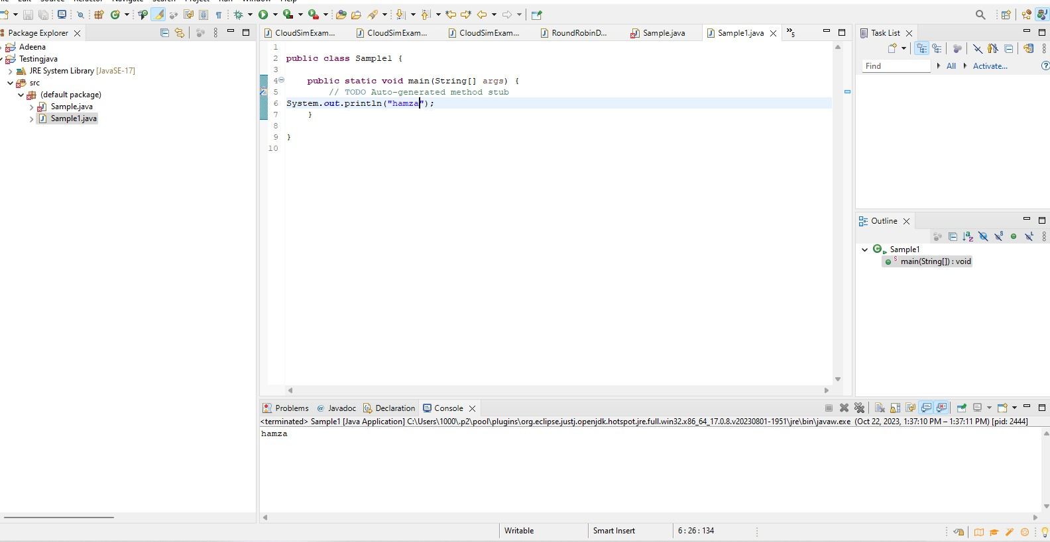

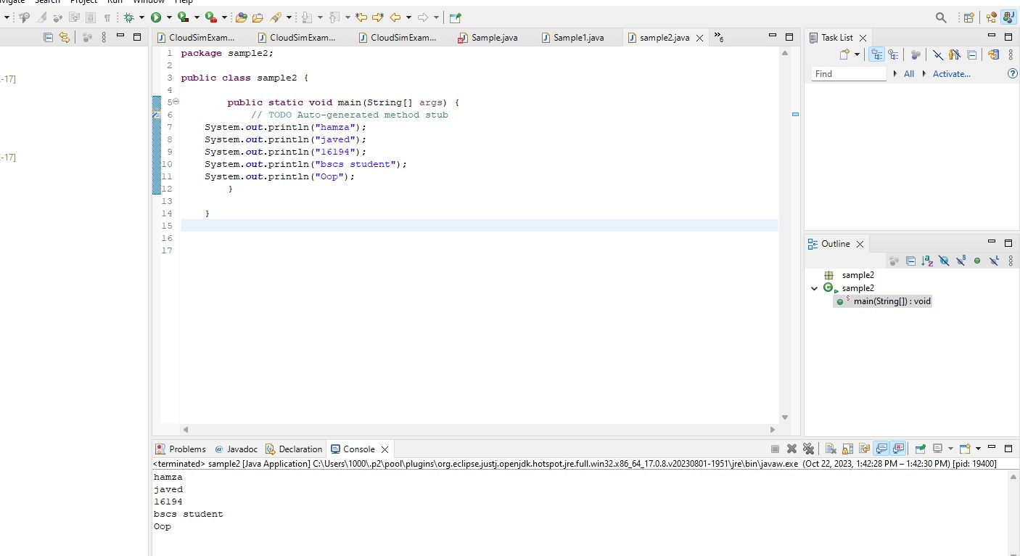

## Conclusion:

In this lab we learn how to design a simple program of java that is hello world and Biodata on Ecllipse software using IDE and notepad using cmd.

**Lab-02**

**Java Programming Elements**

## Objectives:

Learning Input / Output handling on Java console. Understanding variables using primitive and non-primitive data types. Exploring Java’s built in classes.

**Theory:**

**Console input**

System.in to the standard input device. Console input is not directly supported in Java, but Scanner class is used to create an object to read input from System.in, as follows:

Scanner input = new Scanner(System.in);

double radius = input.nextDouble();  
Import the class by adding

import java.util.Scanner;

**Console output**

Java uses System.out to refer to the standard output device.To perform console output, println method is used to display a primitive value or a string to the console.

System.out.print("Hello ");

System.out.println("world");

You can use the System.out.printf method to display formatted output on the console.

System.out.printf(“Your Total amount is %.2f", total);

System.out.printf("count is %d and amount is %f", count, amount);

**Data Types in Java**

A data type in a programming language is a set of data with values having predefined characteristics.

There are two basic types in Java.

1. **Primitive**  
    A primitive type is predefined by the language and is named by a reserved keyword.
2. **Non-Primitive**

It is a reference data type, which are references to objects.

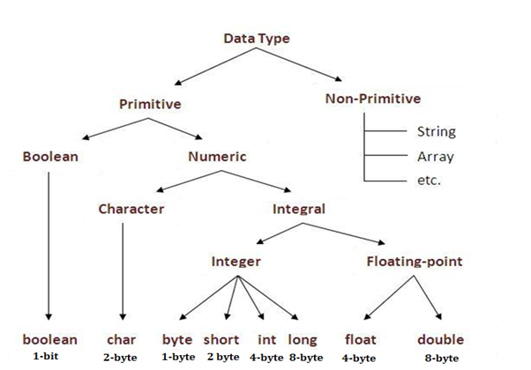

**Figure 2.1: Data Types in Java**

**Variables**

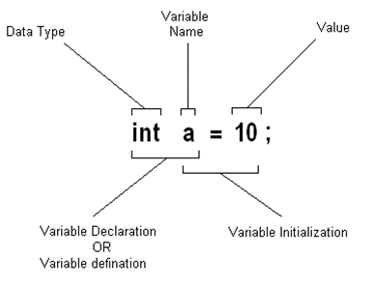

**Figure 2.2: Variable Initialization**

* Variable is a name of memory location.
* It is name of reserved area allocated in memory.
* In the given example; int is data type, a is variable name
* and 10 is the value that a variable holds, followed by a terminator;

**Type Conversion**

Casting is an operation that converts a value of one data type into a value of another data type. The syntax for casting a type is to specify the target type in parentheses, followed by the variable’s name or the value to be cast. For example;

System.out.println((int)1.7);

The above statement displays 1. When a double value is cast into an int value, the fractional part is truncated.

**Some Useful Java Classes**

**Math**

Math class file is included for the definitions of math functions listed below. It is written as java.lang.Math.

Trignometic / Maths Functions

|  |  |
| --- | --- |
| * sin(n) * cos(n) * tan(n) * sinh(n) | * hosh(n) * tanh(n) * pow(nmb,pwr) * sqrt(n) |

**Lab Task:**

1. Design a Java program to take different input from user and store the input in variables with respective data type and then display the data on the console.
2. Design a Java program to explore Math class.
3. Implement the following equation

3x4sin(180x) + 4x3cos(90x) + x2sin(tan(45)) + 7x + 9cos(90x2 )

Where x may be user defined value.

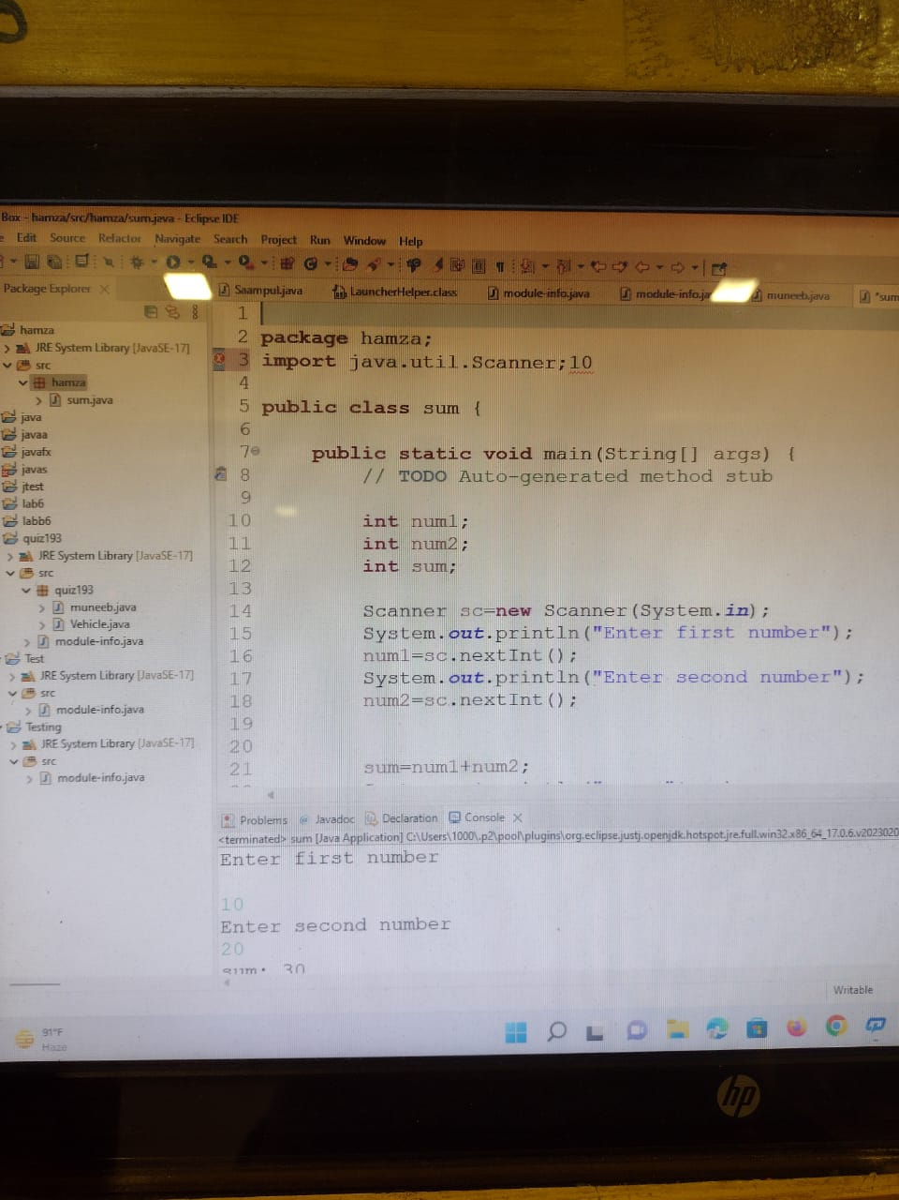

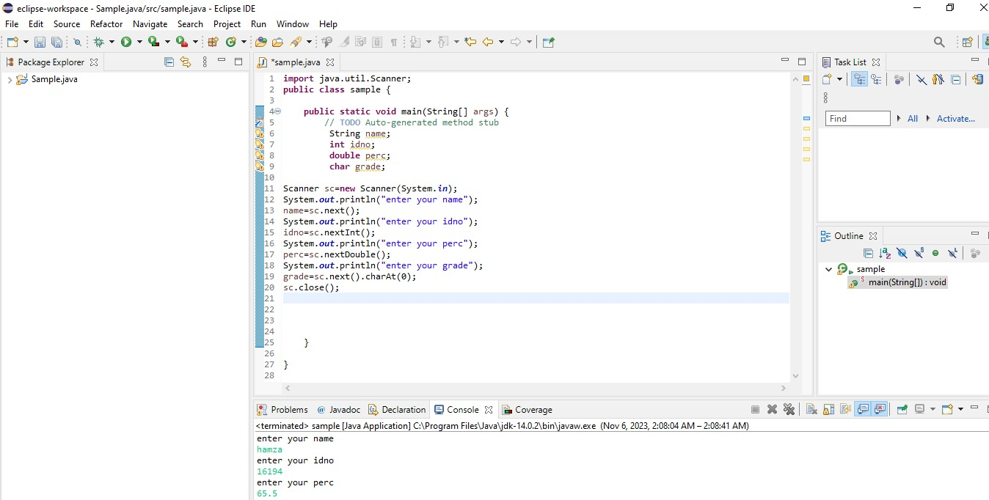

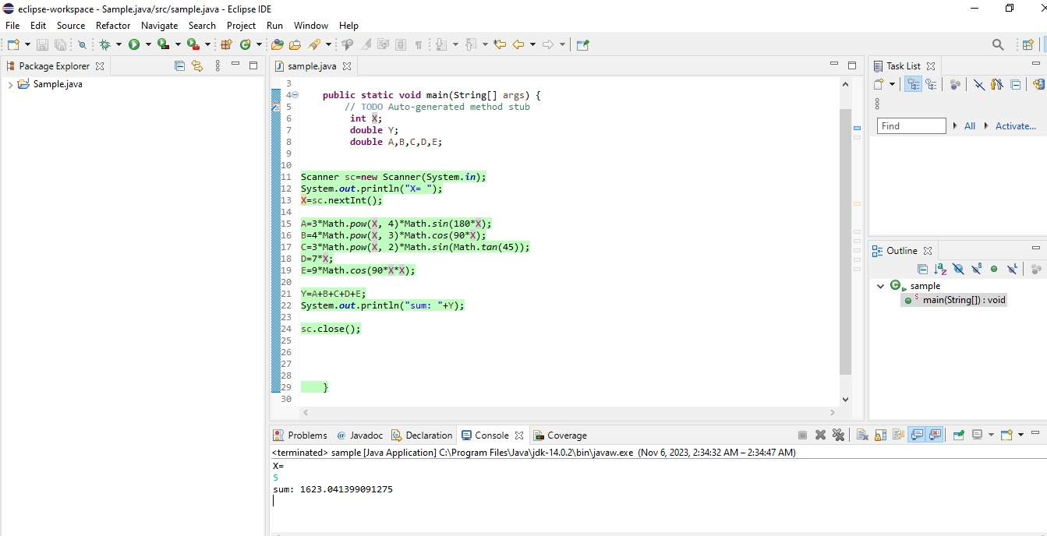

**Conclusion:** In this lab we Learning Input / Output handling on Java console. Understanding variables using primitive and non-primitive data types. Exploring Java’s built in classes. Using different types of math equation and solve it my taking input value from the user.

**Lab-03**

**Classes, Objects & Strings**

**Objectives:**

Understanding concepts of class and object in java. Implementing a class with members including data, methods and constructors also getting familiar with the String class of Java.

**Theory:**

**Class**

A class consists of

* Data(variables)
* Methods
* Constructors

**Strings**

The classes String, StringBuilder, and StringBuffer are used for processing strings. A string is a sequence of characters. Strings are frequently used in programming. In many languages, strings are treated as an array of characters, but in Java a string is treated as an object. A String object is immutable; its contents cannot be changed.

**Syntax:**

String newString = new String(stringLiteral);

String newString = stringLiteral;

The String class provides the methods for comparing strings.

|  |  |
| --- | --- |
| Methods | Description |
| equals(StringLiteral) | Returns true if this string is equal to string s1. |
| equalsIgnoreCase(StringLiteral) | Returns true if this string is equal to string s1 case insensitive. |
| compareTo(StringLiteral) | Returns an integer greater than 0, equal to 0, or less than 0 to indicate whether this string is greater than, equal to, or less than s1 |

**Lab Task:**

class Box {

double width;

double height;

double depth;

// compute and return volume

double volume() {

return width * height * depth;}

}

// ___________ Demo Class ___________

class BoxDemo {

public static void main(String args[]) {

Box mybox1 = new Box();

Box mybox2 = new Box();

double vol;

// assign values to mybox1's instance variables

mybox1.width = 10;

mybox1.height = 20;

mybox1.depth = 15;

/* assign different values to mybox2's

instance variables */

mybox2.width = 3;

mybox2.height = 6;

mybox2.depth = 9;

// get volume of first box

vol = mybox1.volume();

System.out.println("Volume is " + vol);

// get volume of second box

vol = mybox2.volume();

System.out.println("Volume is " + vol);}

}

**Adding Constructor**

class Box {

double width;

double height;

double depth;

// This is the constructor for Box.

Box() {

System.out.println("Constructing Box");

width = 10;

height = 10;

depth = 10;

}

// compute and return volume

double volume() {

return width * height * depth;}

}

**Lab Assignment:**

1. **Create a class Calculator and implement all the basic operations for two objects**

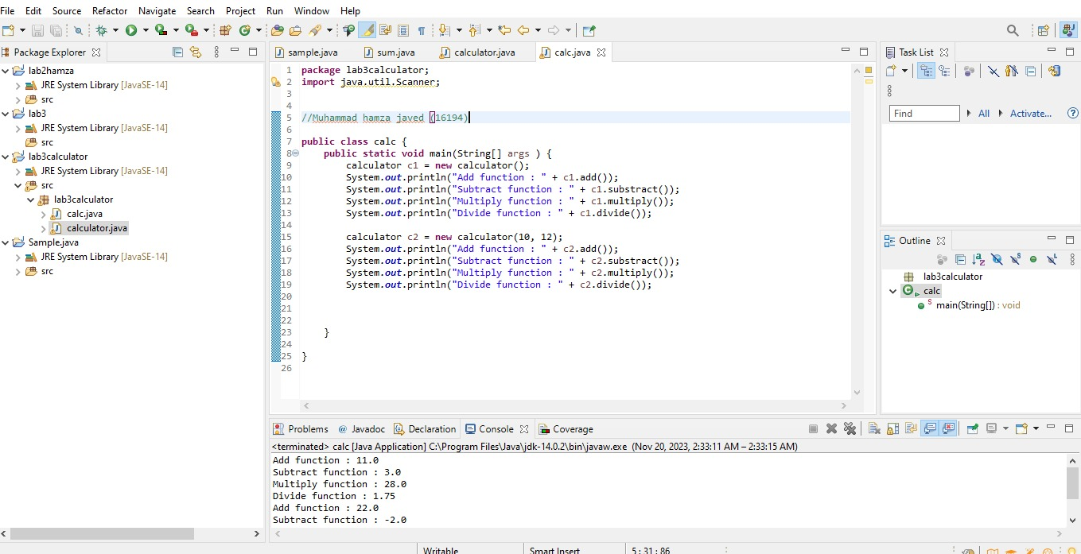

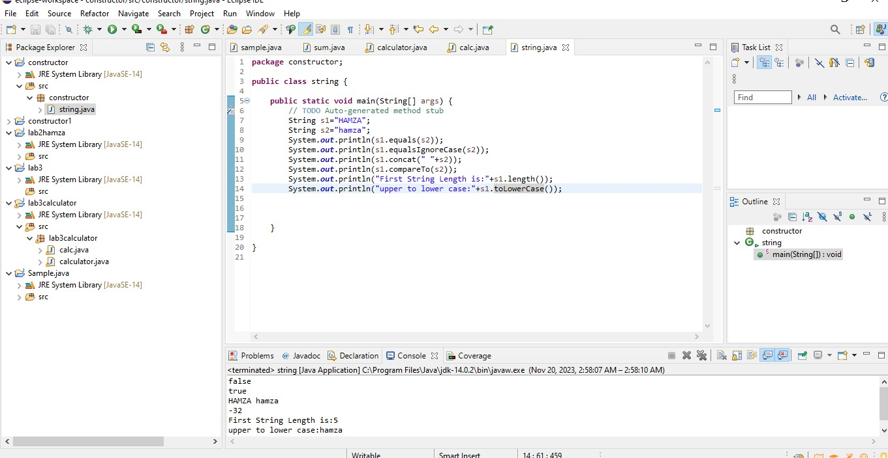

1. **Design a program to explore different methods of String class.**



**Conclusion:** after this lab lab we have to learn about the concept of Classes, Objects & Strings

**Lab-04**

**Overloading & Access Control**

**Objectives:**

Understanding concepts method and constructor overloading. Learn how to provide different access controls on class members

**Theory:**

* **Method Overloading**If a class has multiple methods by same name but different parameters, it is known as Method Overloading.

Three ways to overload a method

In order to overload a method, the parameter list of the methods must differ in either of these:

**1. Number of parameters.**

For example: This is a valid case of overloading

add(int, int)

add(int, int, int)

**2. Data type of parameters.**

For example:

add(int, int)

add(int, float)

**3. Sequence of Data type of parameters.**

For example:

add(int, float)

add(float, int)

**Invalid case of method overloading:**

Parameters list doesn’t mean the return type of the method, for example if two methods have same name, same parameters and have different return type, then this is not a valid method overloading example. This will throw a compilation error.

int add(int, int)

float add(int, int)

**Type Promotion table:**

The data type on the left side can be promoted to any of the data type present at the right side.

byte → short → int → long → double

short → int → long → float → double

int → long → float → double

float → double

long → float → double

char → int → long → float → double

This can be represented as a diagram like this:

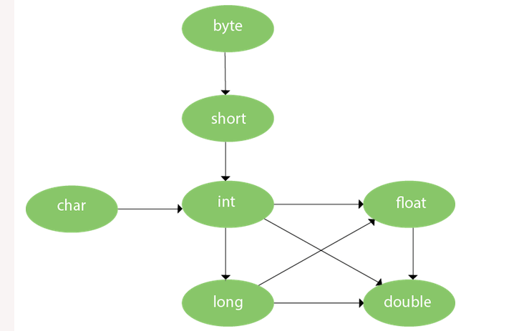

* **Constructor Overloading**If a class has multiple constructors having different parameters, it is known as Constructor Overloading.
* **Access Control**The access modifiers in java specify accessibility (scope) of a data member, method, constructor or class.

There are 4 types of java access modifiers:

1. private
2. default
3. protected
4. public

**Lab Task:**

// Demonstrate method overloading.

classOverloadDemo {

void test() {

System.out.println("No parameters");

}

// Overload test for one integer parameter.

void test(int a) {

System.out.println("a: " + a);

}

// Overload test for two integer parameters.

void test(int a, int b) {

System.out.println("a and b: " + a + " " + b);}

// overload test for a double parameter

double test(double a) {

System.out.println("double a: " + a);

return a*a; }

OverloadDemo(){

System.out.println("No-args constructor ");}

OverloadDemo(int demo){

System.out.println("Parameterized Constructor :" + demo) ;} }

// ___________ Calling Class ___________

class Overload {

public static void main(String args[]) {

OverloadDemo ob = new OverloadDemo();

OverloadDemo ob1 = new OverloadDemo(33);

double result;

// call all versions of test()

ob.test();

ob.test(10);

ob.test(10, 20);

result = ob.test(123.25);

System.out.println("Result of ob.test(123.25): " + result);

}

}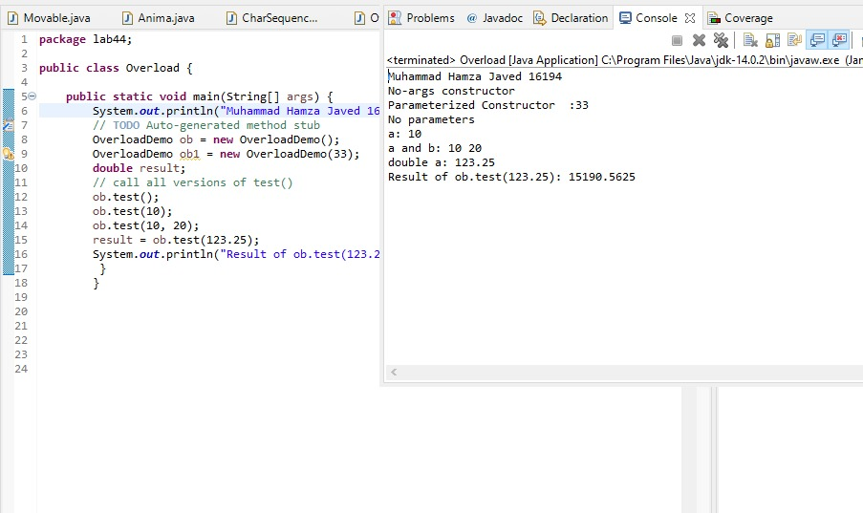

**Lab Assignment:**

**Design a class named Account that contains:**

* A private int data field named id for the account (default 0).
* A private double data field named balance for the account (default 0).
* A private double data field named annualInterestRate that stores the current interest rate (default 0). Assume all accounts have the same interest rate.
* A private Date data field named dateCreated that stores the date when the account was created.
* A no-arg constructor that creates a default account.
* A constructor that creates an account with the specified id and initial balance.
* The accessor and mutator methods for id, balance, and annualInterestRate.
* The accessor method for dateCreated.
* A method named getMonthlyInterestRate() that returns the monthly interest rate.
* A method named getMonthlyInterest() that returns the monthly interest.
* A method named withdraws that withdraws a specified amount from the account.
* A method named deposit that deposits a specified amount to the account.

(Hint: Monthly interest is balance * monthlyInterestRate.

monthlyInterestRate is annualInterestRate / 12.

Note that annualInterestRate is a percentage. You need to divide it by 100.

Design a test program that creates an Account object with an account ID of 1122, a balance of $20,000, and an annual interest rate of 4.5%. Use the withdraw method to withdraw $2,500, use the deposit

method to deposit $3,000, and print the balance, the monthly interest, and the date when this account was created.

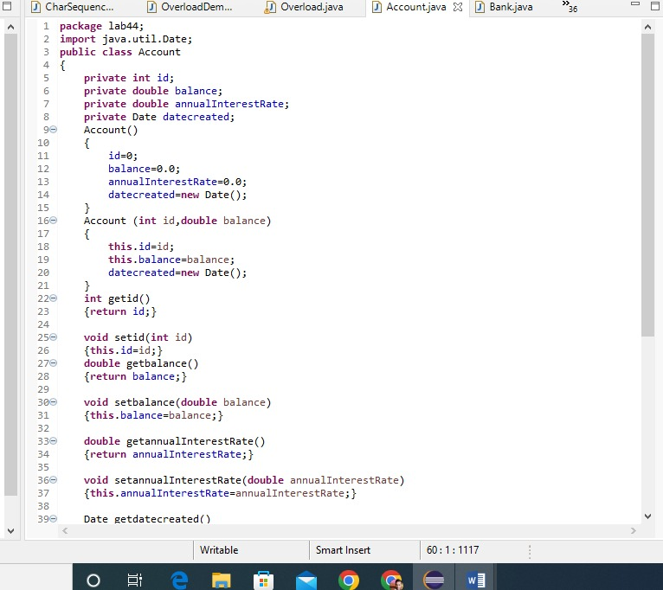

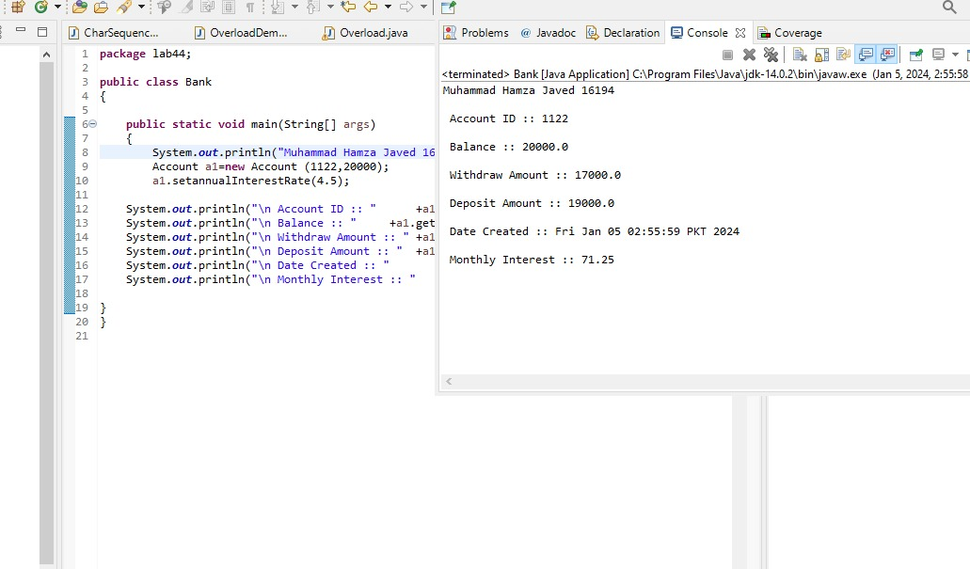

**Conclusion:**

This lab Allow us to understand the concept and method of Constructor and Method Overloading

**Lab-05**

**Java Control Statement, Operators And Arrays.**

**Objectives:**

Understanding the control statements of Java including Loops & if-else.Exploring different operators used in Java and Arrays, array index, single and multi-dimensional arrays, traversing the array using loop

**Theory:**

**Iteration Statements**

A loop can be used to tell a program to execute statements repeatedly. Java provides a powerful construct called a loop that controls how many times an operation or a sequence of operations is performed in succession. A loop can be nested inside another loop. Different form of loops can be nested with one another.

Java provides three types of loop statements:

1. while loops,
2. do-while loops, and
3. for loops.

**Loop Syntax**

|  |  |  |
| --- | --- | --- |
| ***while*** | ***do-while*** | ***for*** |
| while (loop-continuation-condition)  {  // Loop body Statement(s);  } | do {  // Loop body; Statement(s);  }  while (loop-continuation-condition); | for (initial-action;  loop-continuation-condition;  action-after-each-iteration)  {  // Loop body; Statement(s);  } |

**Selection Statements**

Selection Statements of Java programming language decides the next statement for execution. Selection statements use conditions that are Boolean expressions. A Boolean expression is an expression that evaluates to a Boolean value: true or false. An if statement can be inside another if statement to form a nested if statement.

Java provides three types of selection statements:

1. If statements
2. If-else statements
3. If-else if
4. Switch

if statement executes the statements if the condition is true. if-else statement is two way statement that decides which statements to execute based on whether the condition is true or false. Multi-way **if-else** statement is the preferred coding style for multiple alternative if statements.

***If-else* Syntax**

|  |  |  |
| --- | --- | --- |
| ***if*** | ***do-while*** | ***for*** |
| if (boolean-expression)  {  statement(s);  } | **if** (boolean-expression)  {  //for-the-true-case;  } **else** {  //for-the-false-case;  } | **if** (boolean-expression)  {  // for-1st-case;  } **else if(**boolean-expression**)** {  // for-2nd-case;  }  **else** {  //for-default-case;  } |

***Switch* Syntax**

switch (expression) {

case value1:

// statement sequence

break;

case value2:

// statement sequence

break;

.

.

.

casevalueN:

// statement sequence

break;

default:

// default statement sequence

}

**Operators in Java**

There are many operators provide by Java. Following are the most commonly used operators.

**Comparison Operators:**Comparison operators can be used to compare two values. The result of the comparison is a Boolean value: true or false. Java provides six comparison operators.

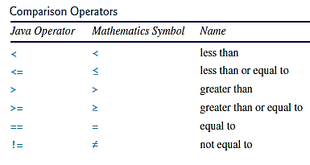

Figure 2.3: Comparison Operators

**Logical Operators:**The logical can be used to create a compound Boolean expression. Sometimes, whether a statement is executed is determined by a combination of several conditions.

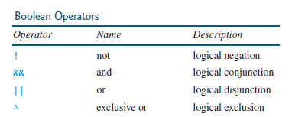

Figure 2.3: Boolean Operators

**Array**

A single array variable can reference a large collection of data. Java and most other high-level languages provide a data structure, the array, which stores a fixed-size sequential collection of elements of the same type. Once an array is created, its size is fixed. An array reference variable is used to access the elements in an array using an index

**Syntax:**

elementType[] arrayRefVar = new elementType[arraySize]; // 1d array

elementType[][] arrayRefVar; // 2d array

To assign values to the elements, use the syntax:

arrayRefVar[index] = value; // 1d array

arrayRefVar[row][column] = value; // 2d array

**Lab Task:**

1. **Design a Java program to use an if-else-if ladder to determine which season a particular month is in.**

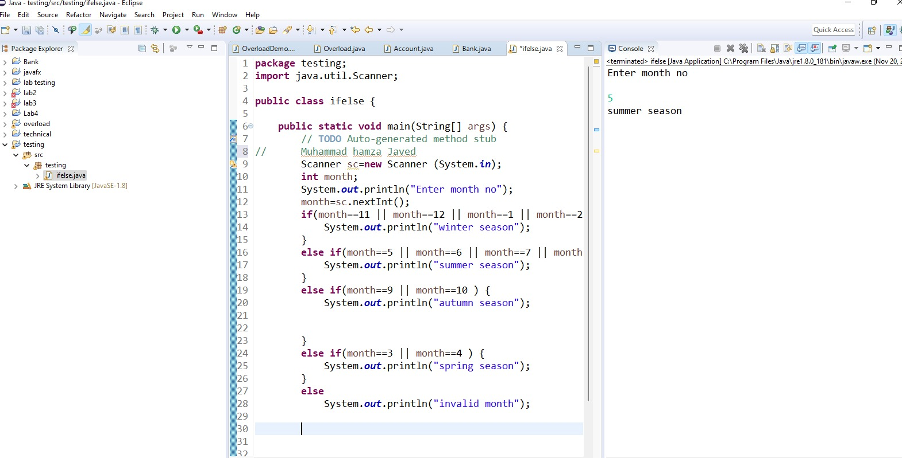

1. **Design a Java program to generate following pattern**

**.....**

**....**

**...**

**..**

**.**

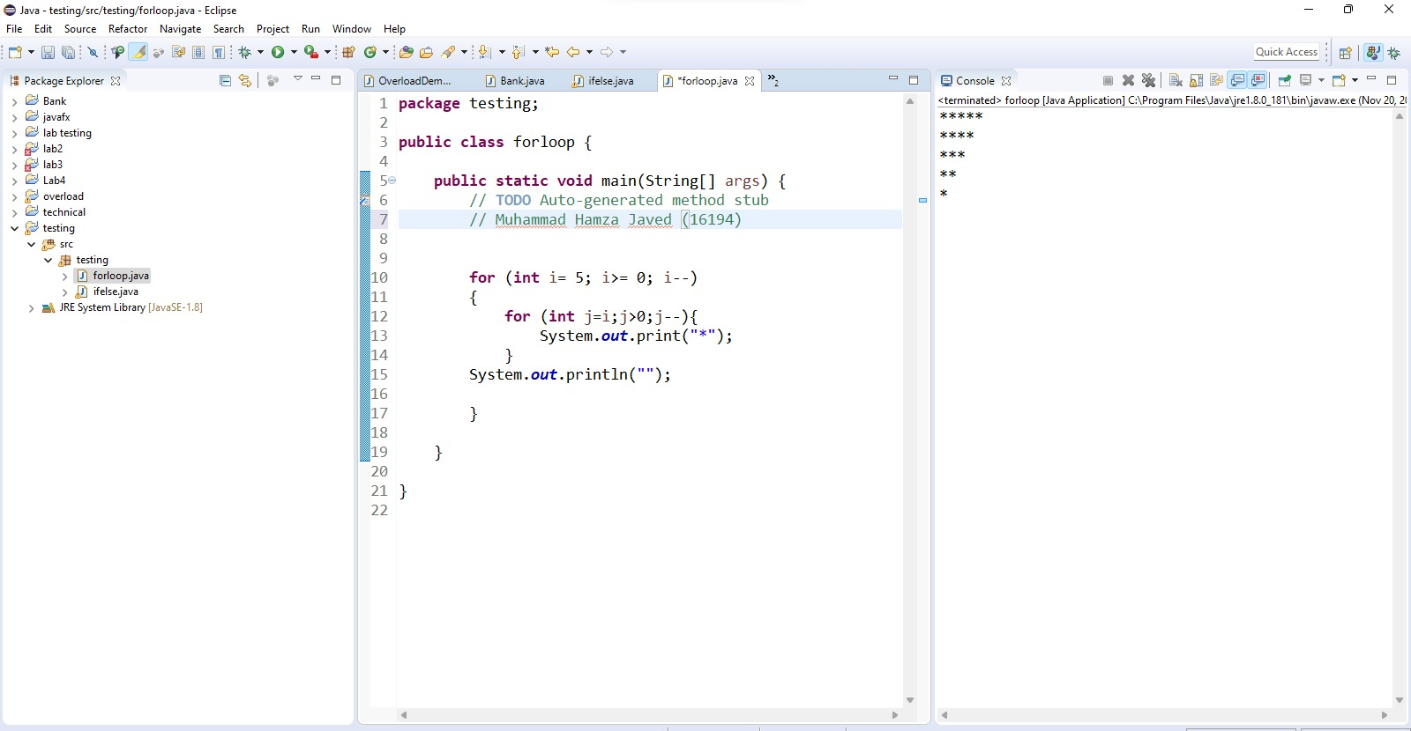

1. **Design a program using one-dimensional array of numbers and finds the average of a set of numbers.**

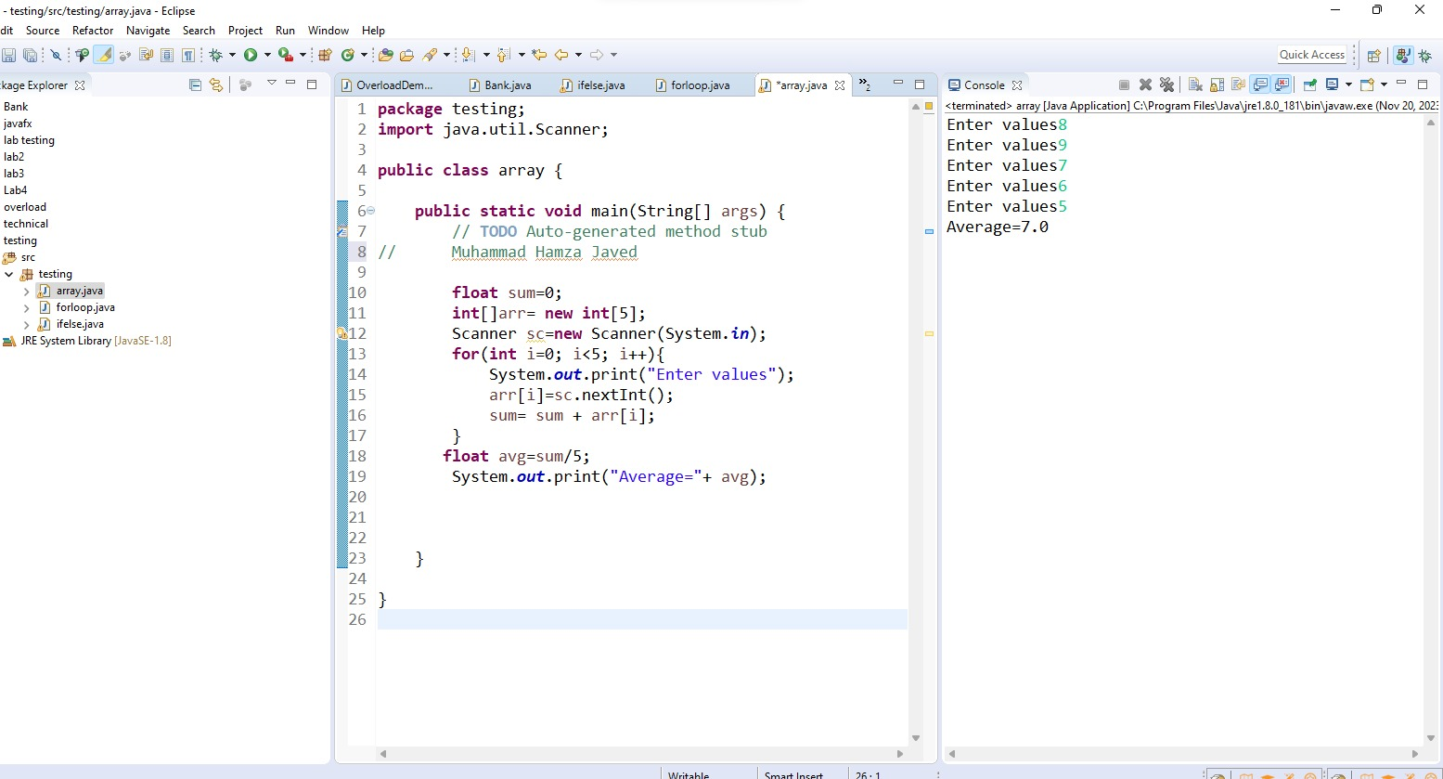

**Lab Assignment:**

1. **Design a program 1 of this lab using *switch* statement.**

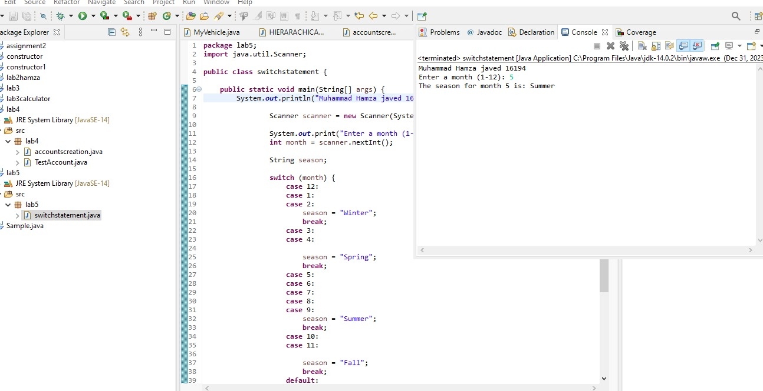

1. **Design a Java program that prompts the user for an integer and then prints out all the prime numbers up to that Integer?**

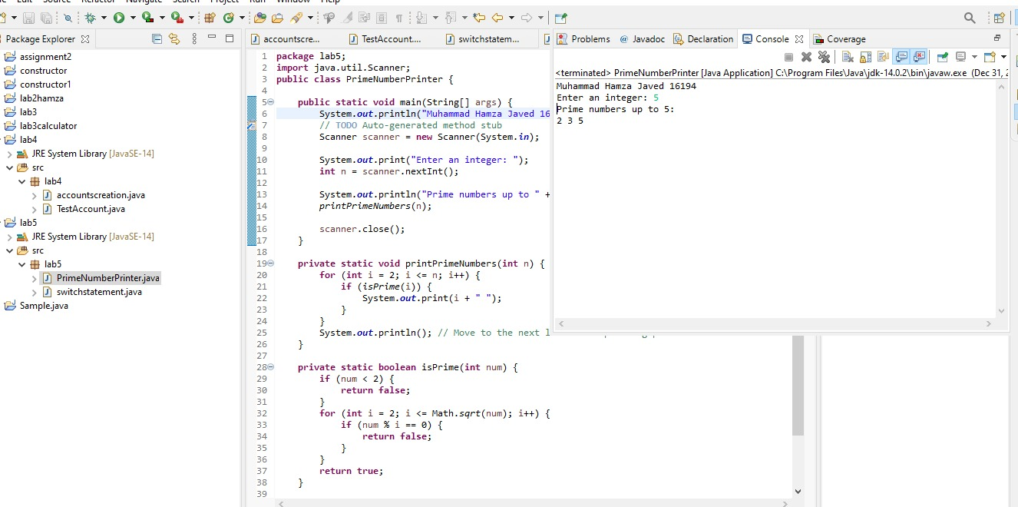

1. **Design a Java program for sorting a given array of numbers in ascending order and descending order?**

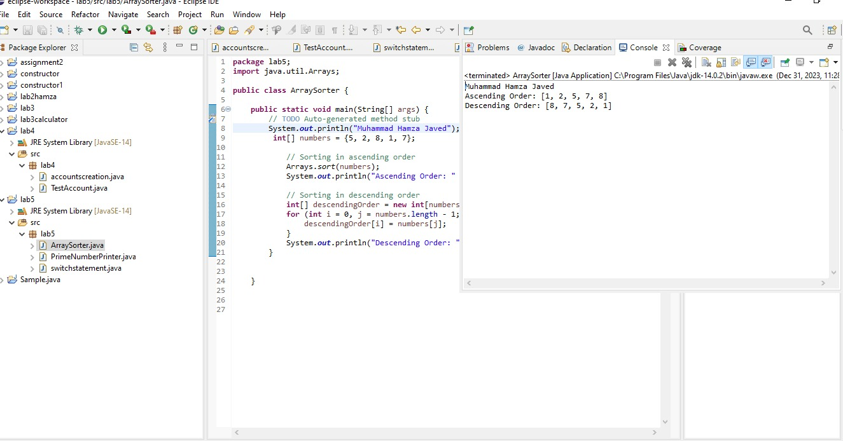

1. **Design a Java program to multiply two given matrices using 2D array.**

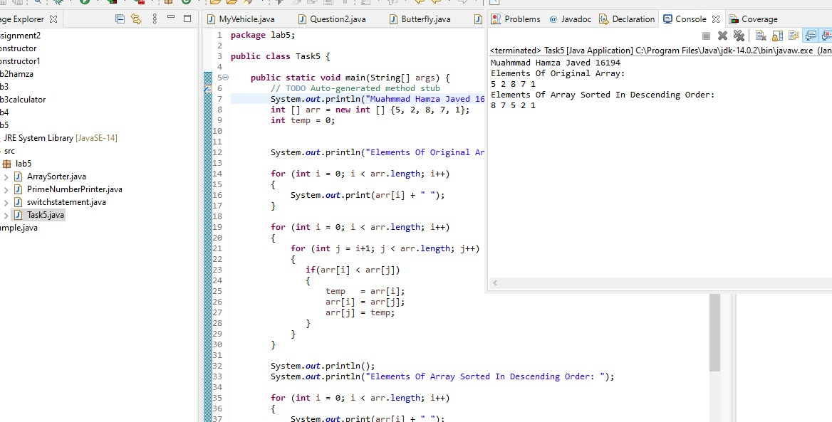

**Conclusion:**

This lab Allow us to understand the concept ava Control Statement, Operators And Arrays**.**

**Lab-06**

**Inheritance and Polymorphism in Java**

**Objectives:**

**Understanding the concept of inheritance, the superclass and subclass and polymorphism**

**Theory:**

**Inheritance**

Inheritance is one of the cornerstones of object-oriented programming because it allows the creation of hierarchical classifications. Using inheritance, you can create a general class that defines traits common to a set of related items. This class can then be inherited by other, more specific classes, each adding those things that are unique to it. In the terminology of Java, a class that is inherited is called a **superclass**. The class that does the inheriting is called a **subclass**. Therefore, a subclass is a specialized version of a superclass. It inherits all of the instance variables and methods defined by the superclass and add its own, unique elements.

**Multilevel Inheritance**

You can build hierarchies that contain as many layers of inheritance as you like. As mentioned, it is perfectly acceptable to use a subclass as a superclass of another. For example, three classes called A, B, and C, C can be a subclass of B, which is a subclass of A. When this type of situation occurs, each subclass inherits all of the traits found in all of its superclasses. In this case, C inherits all aspects of B and A.

**Polymorphism**

Polymorphism is the ability of an object to take on many forms. The most common use of polymorphism in OOP occurs when a parent class reference is used to refer to a child class object.

Any Java object that can pass more than one IS-A test is considered to be polymorphic. In Java, all Java objects are polymorphic since any object will pass the IS-A test for their own type and for the class Object.

**Method Overriding**

In a class hierarchy, when a method in a subclass has the same name and type signature as a method in its superclass, then the method in the subclass is said to override the method in the superclass. When an overridden method is called from within a subclass, it will always refer to the version of that method defined by the subclass. The version of the method defined by the superclass will be hidden.

There are situations when a superclass is created that only defines a generalized form that will be shared by all of its subclasses, leaving it to each subclass to fill in the details. Such a class determines the nature of the methods that the subclasses must implement.

**Lab Task:**

// This program uses inheritance to extend Box.

class Box {

double width;

double height;

double depth;

// construct clone of an object

Box(Box ob) { // pass object to constructor

width = ob.width;

height = ob.height;

depth = ob.depth;

}

// constructor used when all dimensions specified

Box(double w, double h, double d) {

width = w;

height = h;

depth = d;

}

// constructor used when no dimensions specified

Box() {

width = -1; // use -1 to indicate

height = -1; // an uninitialized

depth = -1; // box

}

// constructor used when cube is created

Box(double len) {

width = height = depth = len;

}

// compute and return volume

double volume() {

return width * height * depth;

}

}

// Here, Box is extended to include weight.

class BoxWeight **extends** Box {

double weight; // weight of box

// constructor for BoxWeight

BoxWeight(double w, double h, double d, double m) {

width = w;

height = h;

depth = d;

weight = m;

}

}

class DemoBoxWeight {

public static void main(String args[]) {

BoxWeight mybox1 = new BoxWeight(10, 20, 15, 34.3);

BoxWeight mybox2 = new BoxWeight(2, 3, 4, 0.076);

double vol;

vol = mybox1.volume();

System.out.println("Volume of mybox1 is " + vol);

System.out.println("Weight of mybox1 is " + mybox1.weight);

System.out.println();

vol = mybox2.volume();

System.out.println("Volume of mybox2 is " + vol);

System.out.println("Weight of mybox2 is " + mybox2.weight);

}

}

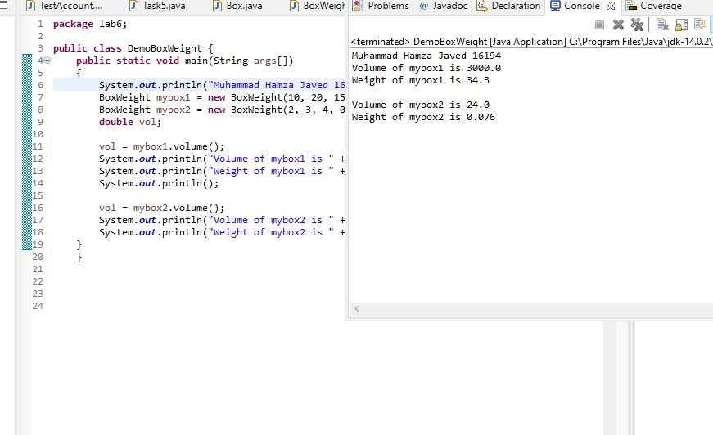

**Multilevel Inheritance**

//edit class BoxWeight

class BoxWeight extends Box {

double weight;

// construct clone of an object

BoxWeight(BoxWeight ob) { // pass object to constructor

super(ob);

weight = ob.weight;

}

// constructor used when all dimensions specified

BoxWeight (double w, double h, double d,double m)

{

super (w,h,d);

weight = m;

}

// constructor used when no dimensions specified

BoxWeight() {

super();

weight = -1; // use -1 to indicate an uninitialized box

}

// constructor used when cube is created

BoxWeight(double len,double m) {

super(len);

weight=m;

}

}

// Add shipping costs.

class Shipment **extends** BoxWeight {

double cost;

// construct clone of an object

Shipment(Shipment ob) { // pass object to constructor

super(ob);

cost = ob.cost;

}

// constructor when all parameters are specified

Shipment(double w, double h, double d, double m, double c) {

super(w, h, d, m); // call superclass constructor

cost = c;

}

// default constructor

Shipment() {

super();

cost = -1;

}

// constructor used when cube is created

Shipment(double len, double m, double c) {

super(len, m);

cost = c;

}

}

class DemoShipment {

public static void main(String args[]) {

Shipment shipment1 = new Shipment(10, 20, 15, 10, 3.41);

Shipment shipment2 = new Shipment(2, 3, 4, 0.76, 1.28);

double vol;

vol = shipment1.volume();

System.out.println("Volume of shipment1 is " + vol);

System.out.println("Weight of shipment1 is " + shipment1.weight);

System.out.println("Shipping cost: $" + shipment1.cost);

System.out.println();

vol = shipment2.volume();

System.out.println("Volume of shipment2 is " + vol);

System.out.println("Weight of shipment2 is " + shipment2.weight);

System.out.println("Shipping cost: $" + shipment2.cost);

}

}

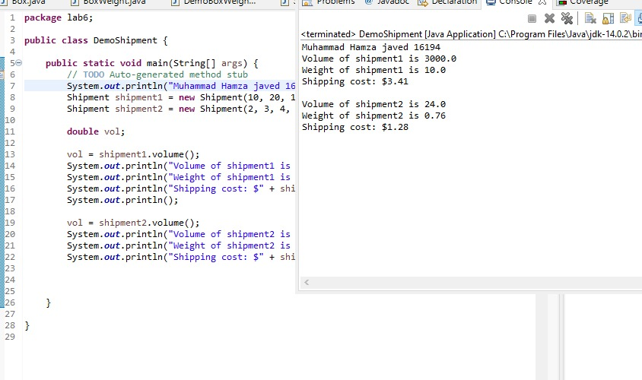

**Lab Assignment:**

1. **Design a class named Person and its two subclasses named Student and Employee. Make Faculty and Staff subclasses of Employee.**

**(The Person, Student, Employee, Faculty, and Staff classes)**

**A person has a name, address, phone number, and email address. A student has a class status (freshman, sophomore, junior, or senior). Define the status as a constant. An employee has an office, salary, and date hired. A faculty member has office hours and a rank. A staff member has a title. Override the toString method in each class to display the class name and the person’s name.**

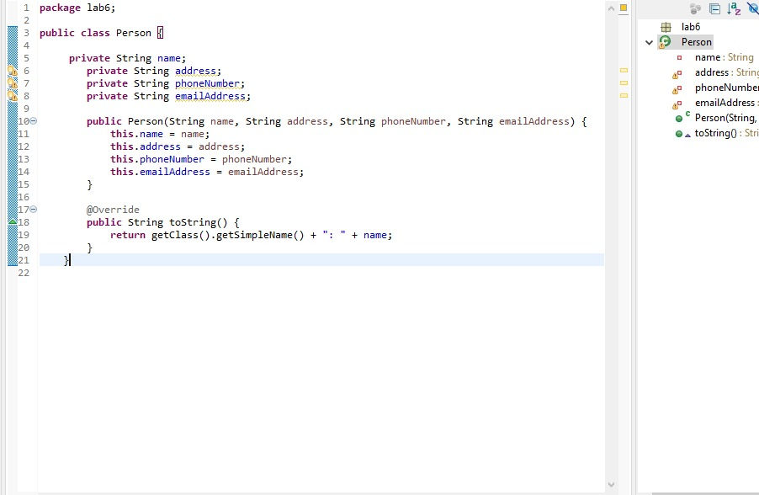

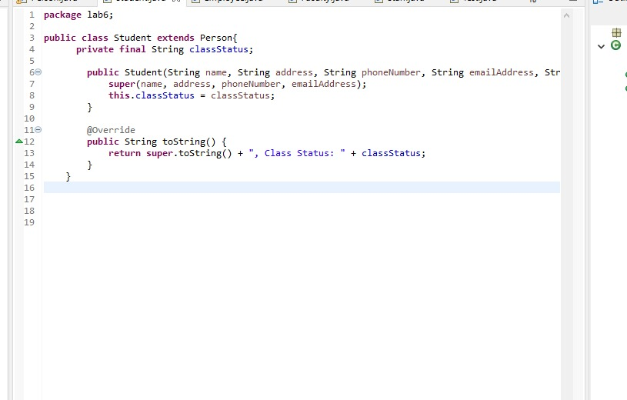

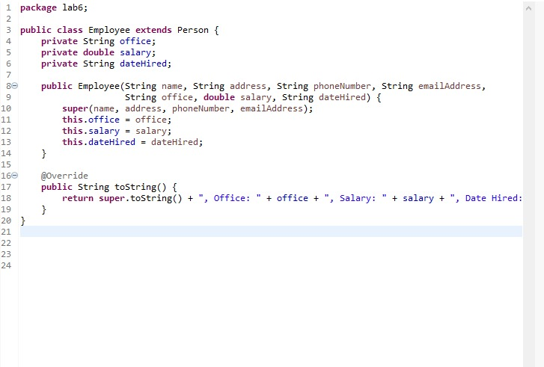

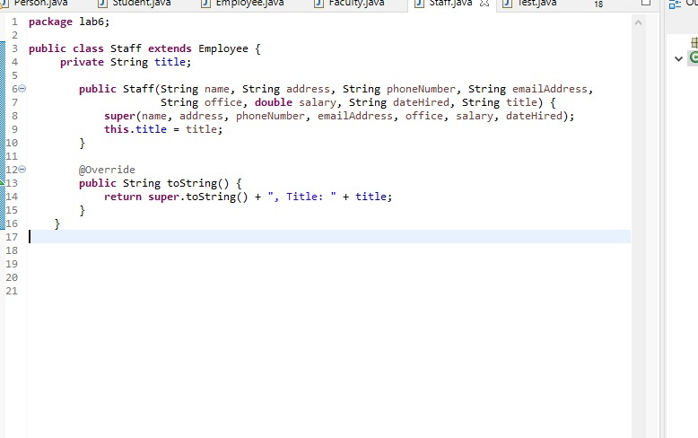

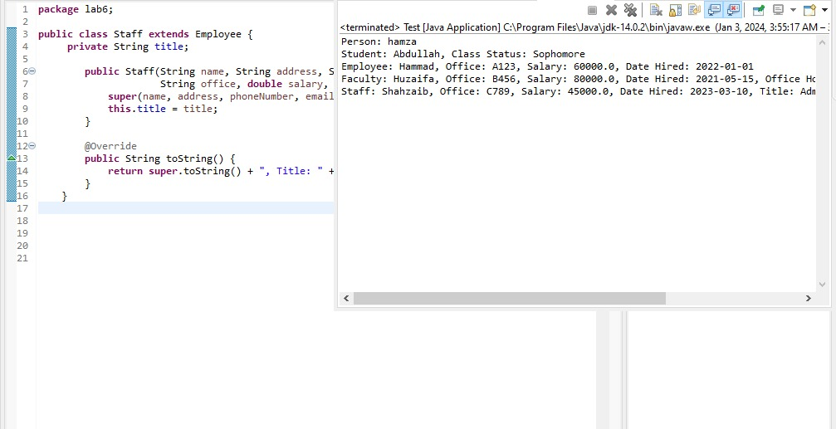

1. **Design a test program that creates a Person, Student, Employee, Faculty, and Staff, and invokes their toString() methods.**

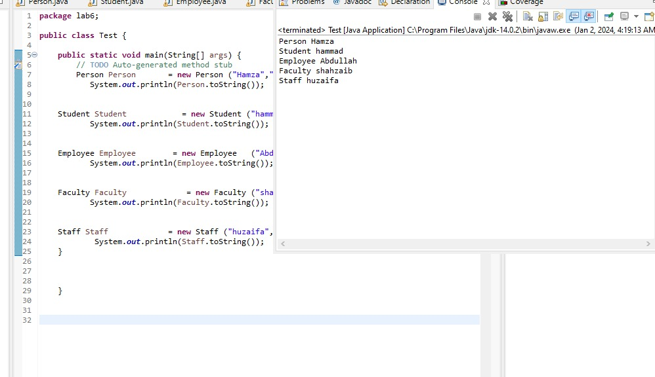

}

**Conclusion:**

At the end of this lab we knows the concept and used of Inheritance.

**Lab-07**

**Use of abstract & final**

**Objectives:**

Understand the abstract method & class and final method and class.

**Theory:**

**Abstract Methods**

There are cases when we have to create a superclass that only defines a generalized form that will be shared by all of its subclasses, leaving it to each subclass to fill in the details.

In order to ensure that a subclass does, indeed, override all necessary methods, Java provides abstract methods. Certain methods can be made mandatory to be overridden by subclasses by specifying the abstract type modifier.

To declare an abstract method, use this general form:

*abstract type name(parameter-list);*

**Abstract Class**

Any class that contains one or more abstract methods must also be declared abstract. To declare a class abstract, ***abstract*** keyword is used in front of the class keyword at the beginning of the class declaration.

*abstract class class_name {*

*abstract type method();*

*}*

There can be **no** objects of an abstract class.

**Final Method**

***Final*** can be use to prevent overriding. To disallow a method from being overridden, specify ***final*** as a modifier at the start of its declaration. Methods declared as final cannot be overridden.

To declare final method, use this general form:

*final type name(parameter-list){}*

**Final Class**

***Final*** can be use to prevent inheritance. In order to prevent a class from being inherited, the class is made final. Declaring a class as final implicitly declares all of its methods as final, too.

To do this, precede the class declaration with ***final***.

*final class class_name{ }*

It is illegal to declare a class as both abstract and final.

**Lab Task:**

// A Simple demonstration of abstract.

abstract class A {

abstract void callme();

// concrete methods are still allowed in abstract classes

void callmetoo() {

System.out.println("This is a concrete method.");

}

}

class B extends A {

void callme() {

System.out.println("B's implementation of callme.");

}

}

class AbstractDemo {

public static void main(String args[]) {

B b = new B();

b.callme();

b.callmetoo();

}

}

**Using *final* to Prevent Overriding**

class A {

final void meth() {

System.out.println("This is a final method.");

}

}

class B extends A {

void meth() { // ERROR! Can't override.

System.out.println("Illegal!");

}

}

**Using *final* to Prevent Inheritance**

final class A {

void meth() {

System.out.println("This is by default final method.");

}

}

class B extends A {

void meth() { // ERROR! Can't override.

System.out.println("Illegal!");

}

}

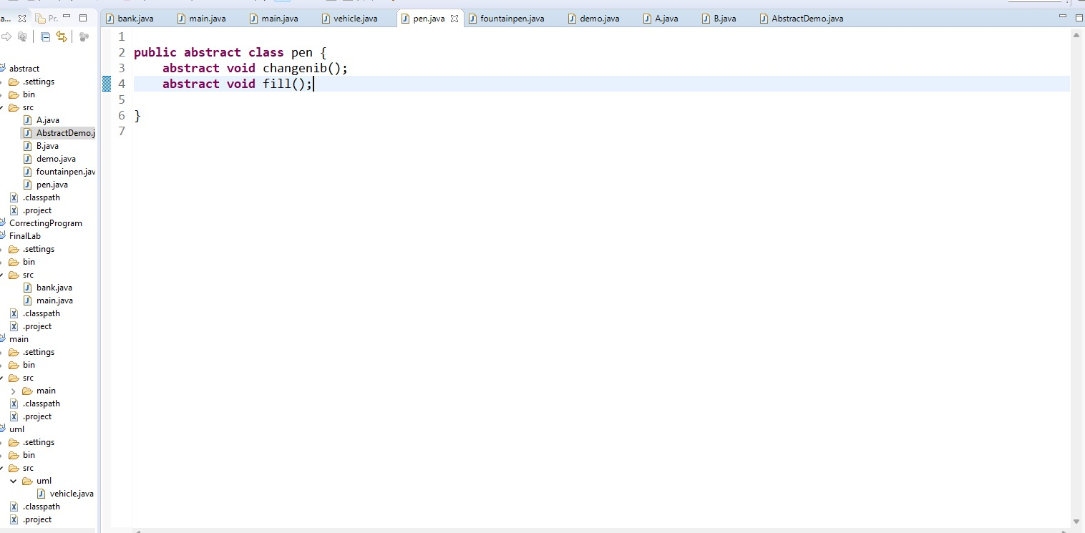

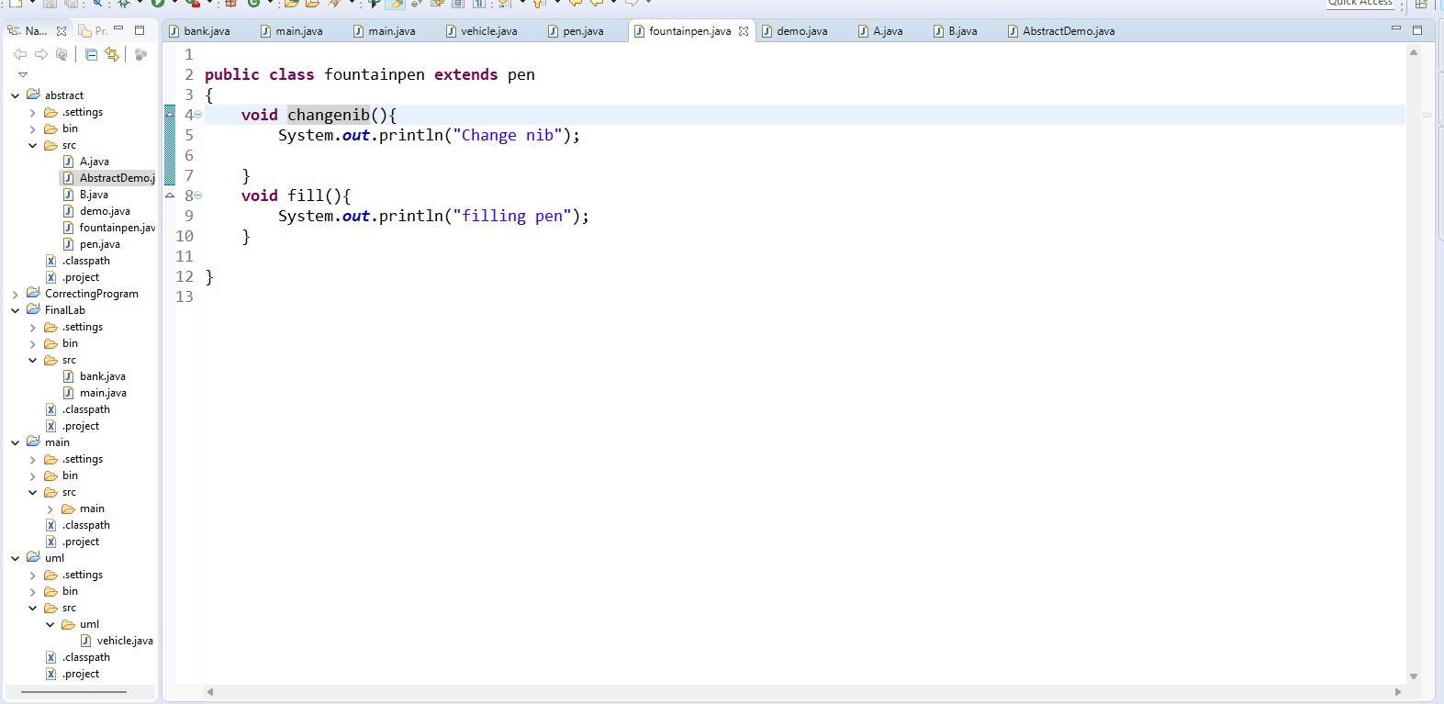

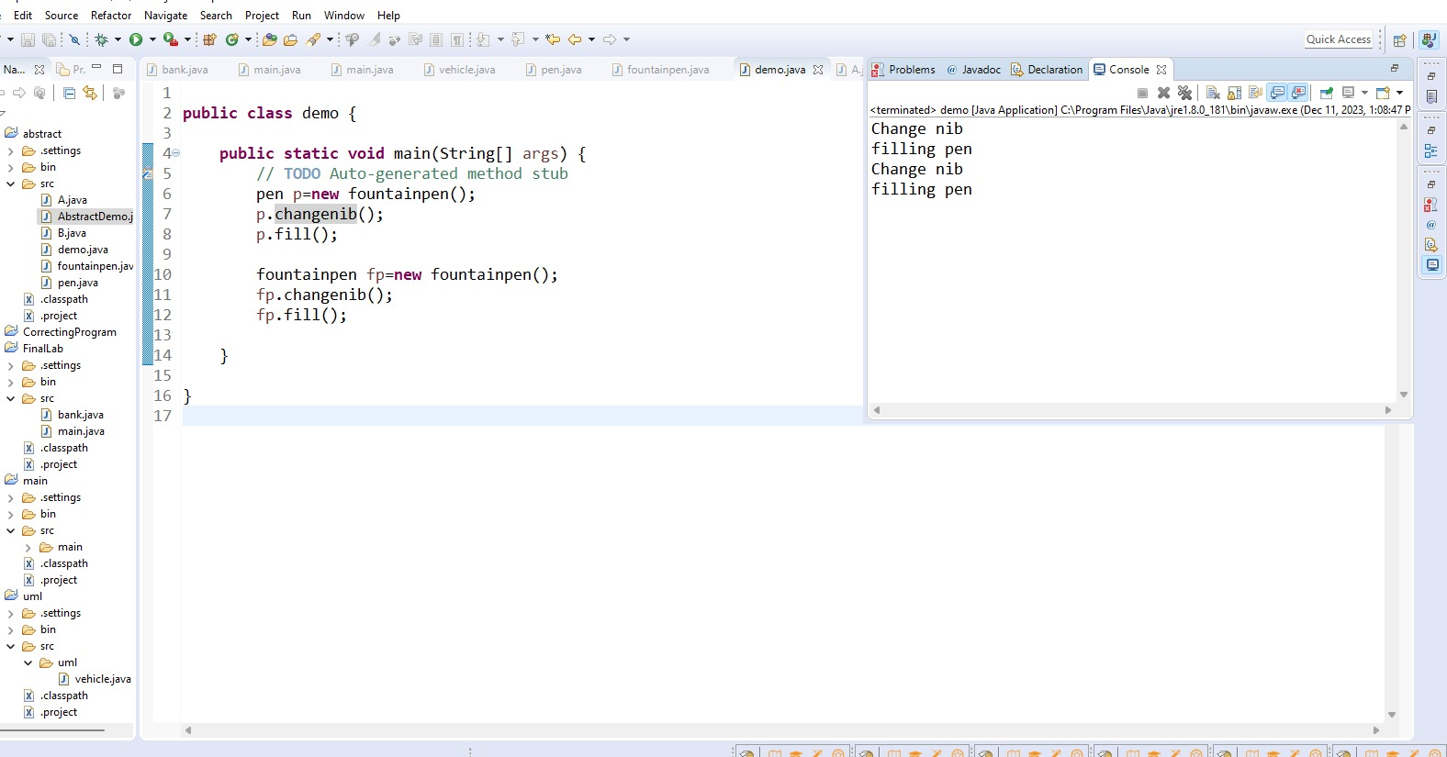

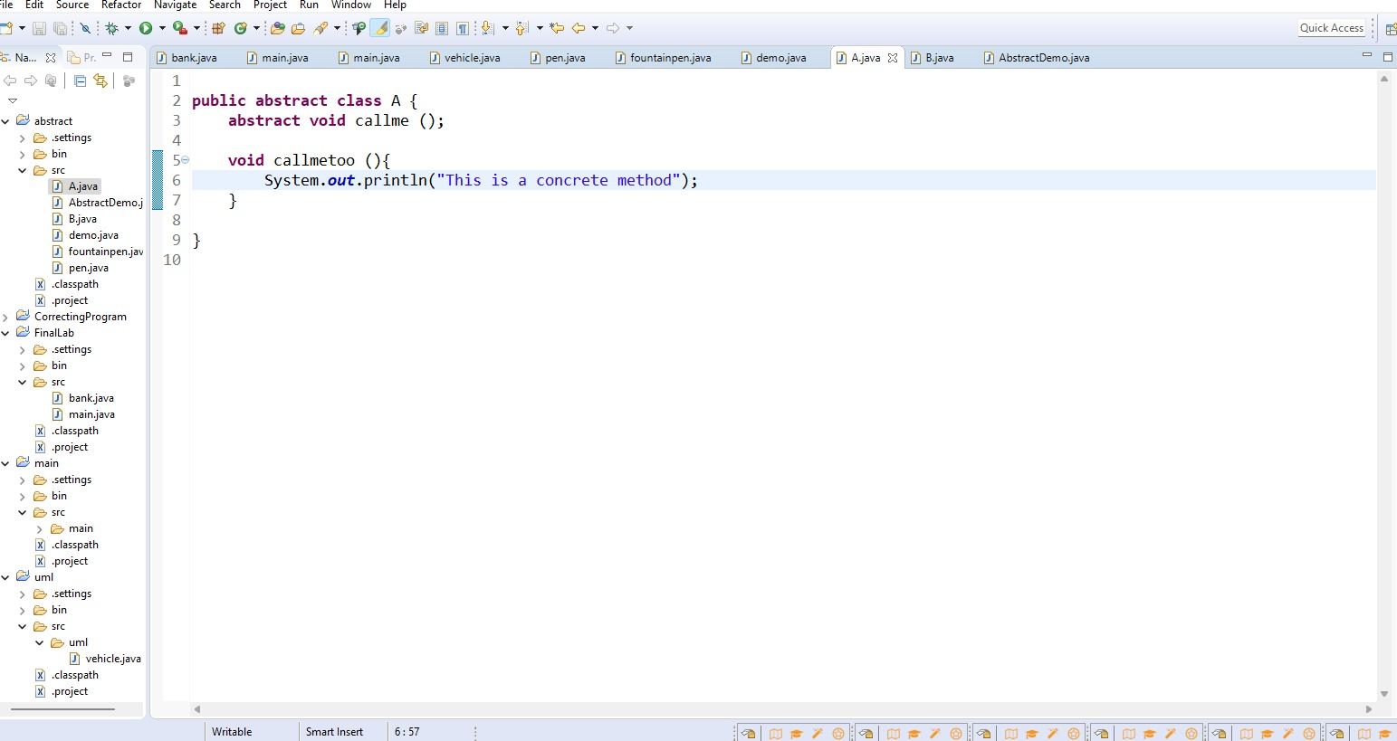

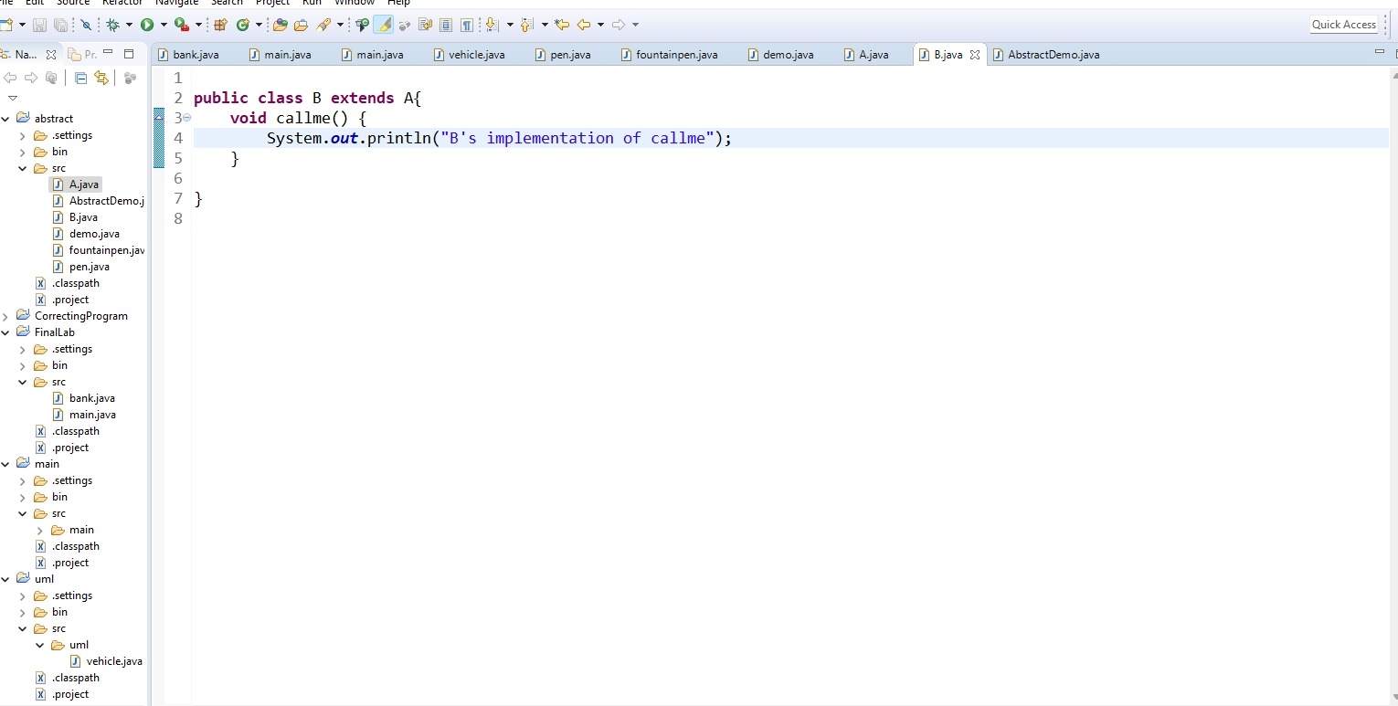

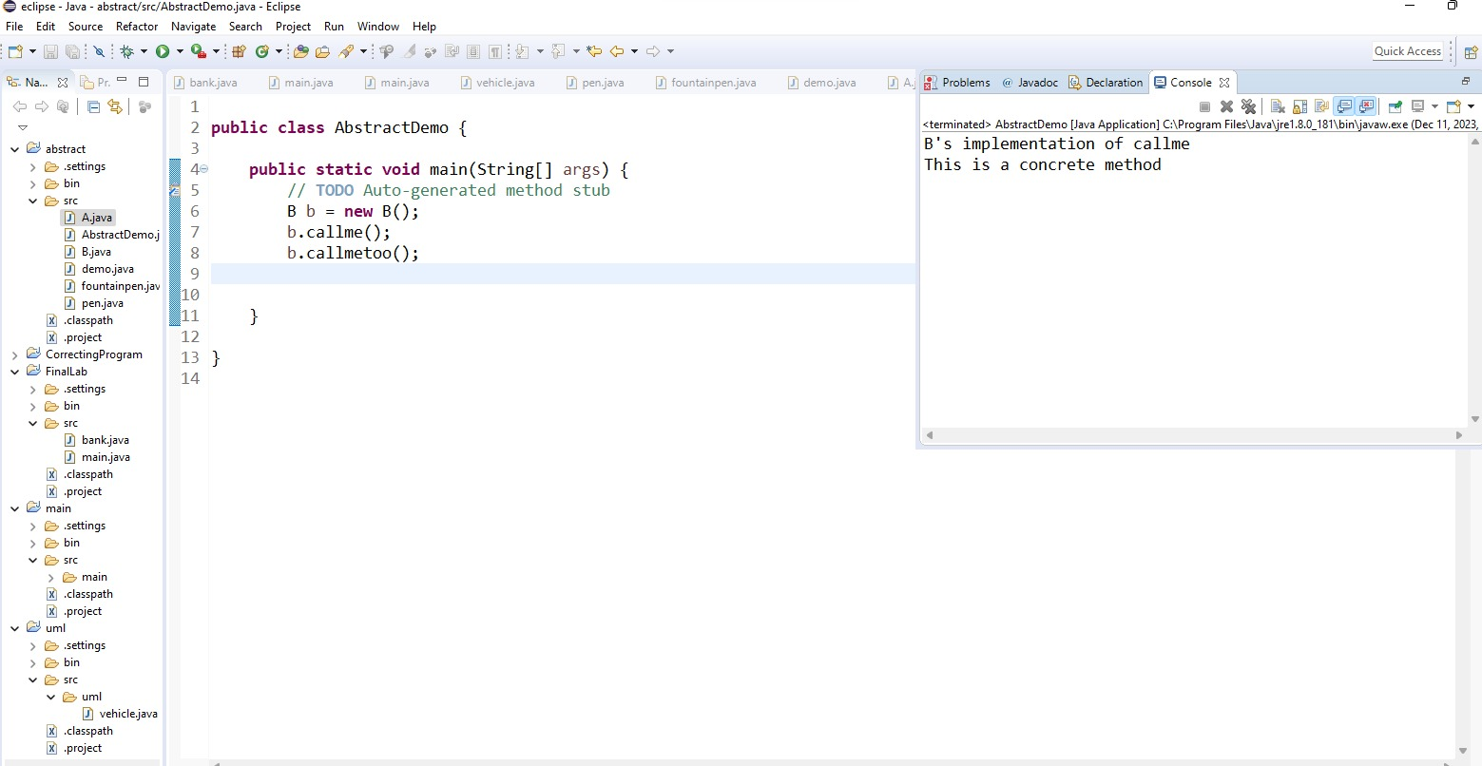

**Lab Assignment:**

1. **Consider developing a simple bank application as per given details.**

The project contains different classes. One class is **Account** which is abstract. The Account class should implement following details;

* List of attributes:

protected String id;

protected double balance;

* Implement the following constructor:

public Account(String id, double balance) // this constructor will be used from a sub-class's constructor.

* List of methods:

public String getID() // Returns the account id.

public double getBalance() // Returns the current balance.

Public *abstract* booleanwithdraw(double amount)

Public *abstract* void deposit(double amount)

Second class is **SavingsAccount** which extends from Account. The SavingsAccount class should implement following details;

* Implement the following constructor:

Public SavingsAccount(String id, double initialDeposit): // the initial deposit passed will be at least $10.

* List of methods:

public void deposit(double amount): // The provided amount is added to the account

public boolean withdraw(double amount):

Implement the withdraw method to take out the provided amount from the account balance. Incorporate the transaction fee $2 per withdrawal. A withdrawal that potentially lowers the balance below $10 is not allowed. The balance remains unchanged but the method returns false. If the withdrawal succeeds, the method returns true.

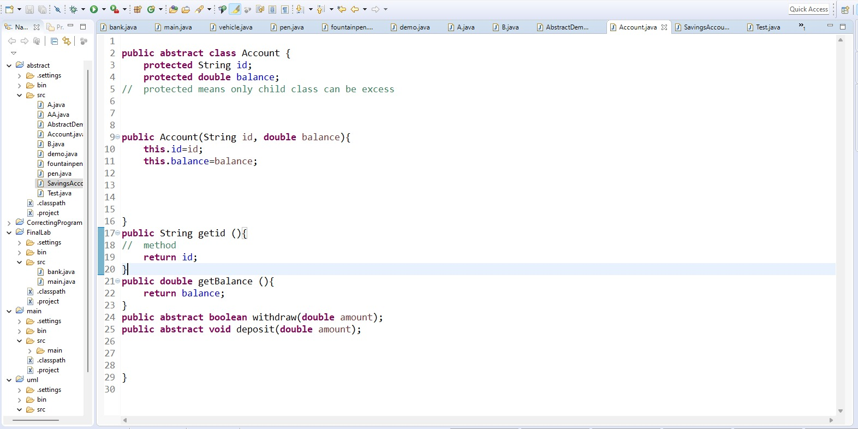

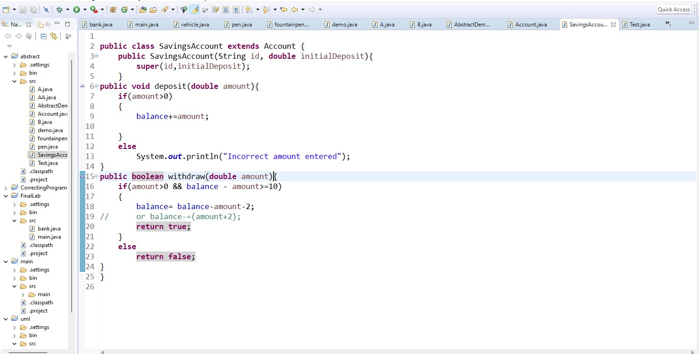

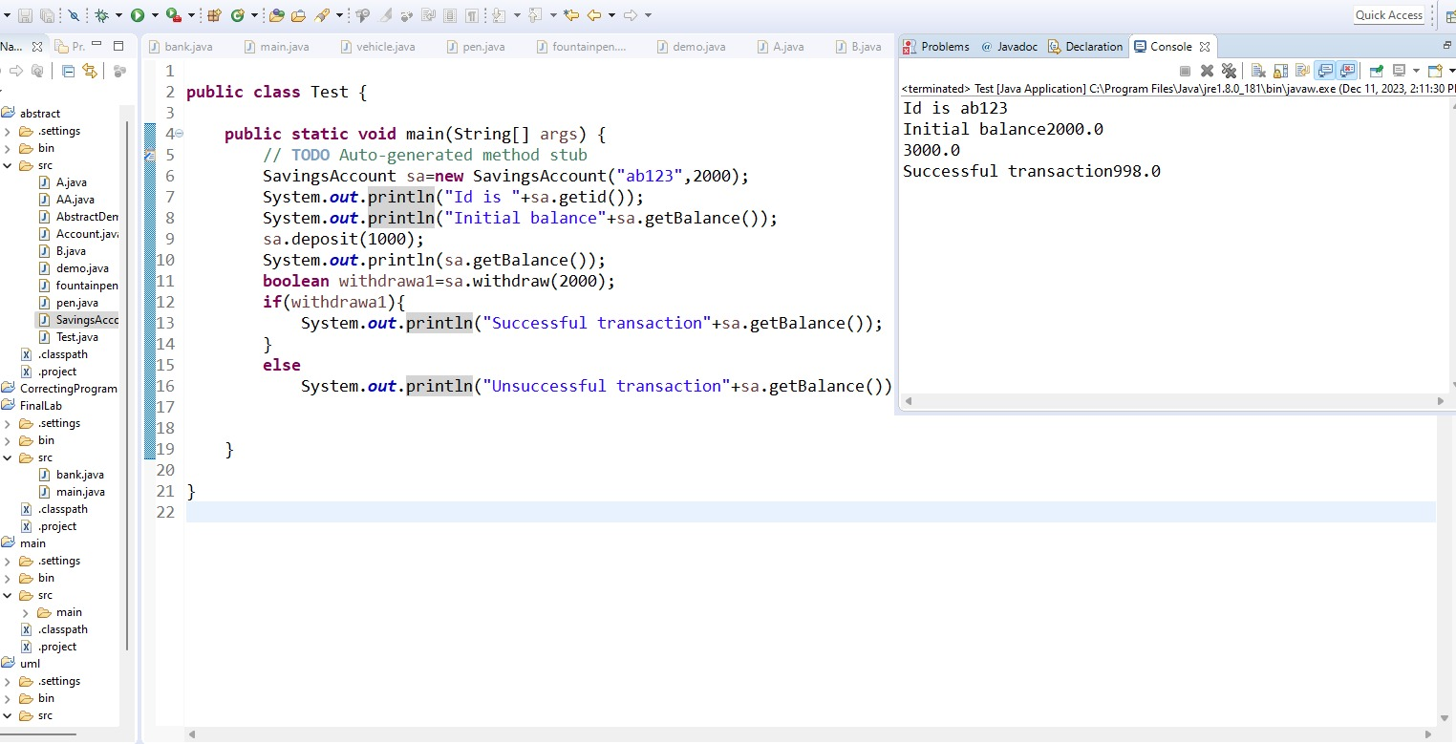

**Conclusion:**

After this lab we understand the concept of Abstraction .

package quiz;

public abstract class Account {

}protected String id ;

protected double balence;

public Account(String id,double balence)

{

this.id = id;

this.balence = balence;

}

public void setid()

{

System.out.println("15513");

}

public String getId()

{

return this.id;

}

public void setbalence()

{

System.out.println("5000 rupes");

}

public double getbalence()

{

return this.balence;

}

public abstract void deposit(double amount);

public abstract double withdraw(double amount);

}

SAVINGS ACCOUNT

package quiz;

public abstract class SavingsAccount extends Account{

double initialDeposit=500;

double withdrew_amount;

double amount= 2000;

public SavingsAccount(String id, double balance, double inititalDeposit) {

super(id, balance);

this.initialDeposit= initialDeposit;

**Lab - 08**

**Packages & Interfaces**

**Objectives:**

**Understanding the concept packages & interfaces of Java.**

**Theory:**

**Packages**  
Packages are containers for classes that are used to keep the class name space compartmentalized. For example, a package allows you to create a class named List, which you can store in your own package without concern that it will collide with some other class named List stored elsewhere. Packages are stored in a hierarchical manner and are explicitly imported into new class definitions.

This is the general form of the package statement:

packagepkg;

This is the general form of the import statement:

import pkg1[.pkg2].(classname|*);

**Interface**Using interface, you can specify a set of methods that can be implemented by one or more classes. The interface, itself, does not actually define any implementation. Although they are similar to abstract classes, interfaces have an additional capability: A class can implement more than one interface. By contrast, a class can only inherit a single superclass (abstract or otherwise).

**Lab Task:**

// A simple package

**Package** MyPack;

class Balance {

String name;

Double bal;

Balance(String n, double b) {

name = n;

bal = b;

}

void show() {

if(bal<0)System.out.print("--> ");

System.out.println(name + ": $" + bal);

} }

Class AccountBalance {

public static void main(String args[]) {

Balance current[] = new Balance[3];

current[0] = new Balance("K. J. Fielding", 123.23);

current[1] = new Balance("Will Tell", 157.02);

current[2] = new Balance("Tom Jackson", -12.33);

for(inti=0; i<3; i++) current[i].show();

}

}

Call this file AccountBalance.java and put it in a directory called MyPack. Next, compile the file. Make sure that the resulting .class file is also in the MyPack directory. Then, try executing the AccountBalance class, using the following command line:

Java MyPack.AccountBalance

Remember, you will need to be in the directory above MyPack when you execute this command.(Alternatively, you can use one of the other two options described in the preceding section to specify the path MyPack.)

As explained, AccountBalance is now part of the package MyPack. This means that it cannot be executed by itself. That is, you cannot use this command line:

Java AccountBalance

AccountBalance must be qualified with its package name.

**Interface implementation**

interface Callback {

void callback(int param);

}

class Client implements Callback {

// Implement Callback's interface

public void callback(int p) {

System.out.println("callback called with " + p);

}

}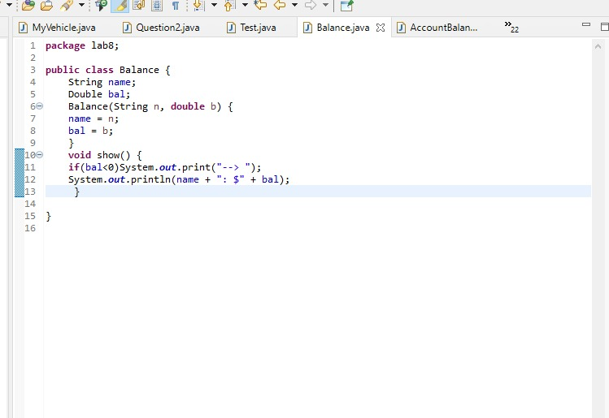

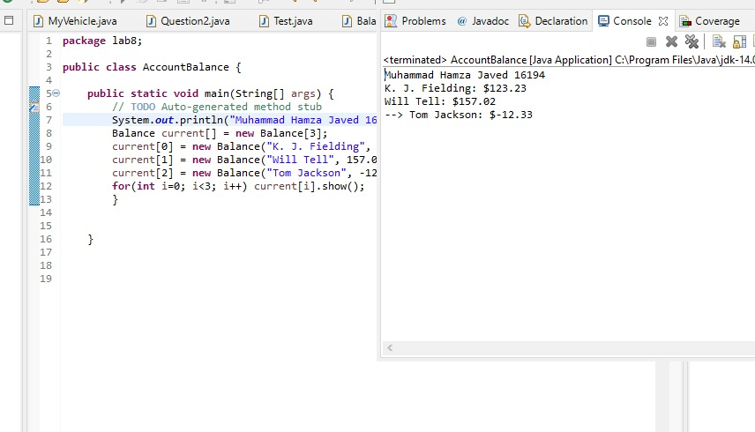

**interface Animal**

**{**

**public void move();**

**}**

**interface Predator**

**{**

**public void hunt();**

**}**

**class Wolf implements Animal, Predator**

**{**

**private int length;**

**public void move()**

**{**

**System.out.println("Wolf is moving!");**

**}**

**public void hunt()**

**{**

**System.out.println("Wolf is hunting!");**

**}**

**}**

**class Fox implements Animal, Predator**

**{**

**private String fur;**

**public void move()**

**{**

**System.out.println("Fox is moving!");**

**}**

**public void hunt()**

**{**

**System.out.println("Fox is hunting!");**

**}**

**}**

**import java.util.ArrayList;**

**class AnimalPredators**

**{**

**public static void main(String[] args) {**

**ArrayList<Animal> animals=new ArrayList<Animal>();**

**animals.add(new Wolf());**

**animals.add(new Fox());**

**animals.add(new Fox());**

**for(Animal animal: animals)**

**animal.move();**

**ArrayList<Predator> predators=new ArrayList<Predator>();**

**predators.add(new Wolf());**

**predators.add(new Fox());**

**predators.add(new Fox());**

**for(int i=0; i<predators.size(); i++)**

**predators.get(i).hunt();**

**}**

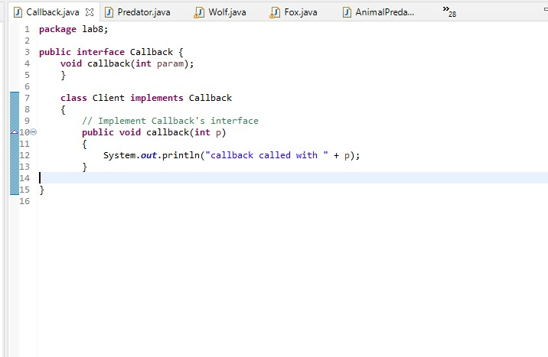

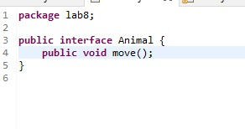

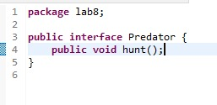

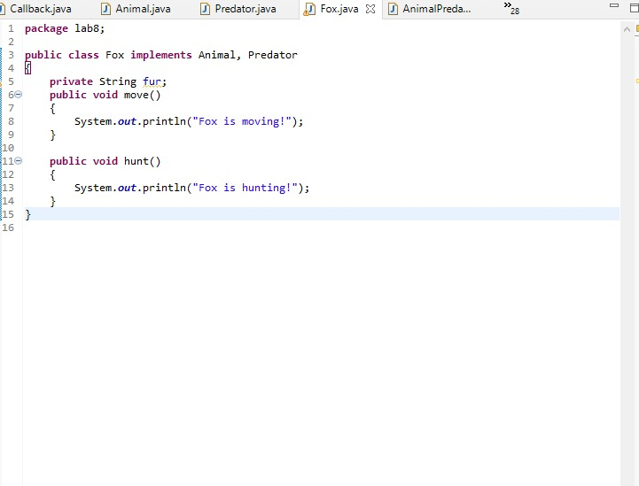

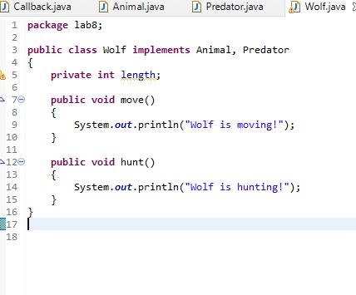

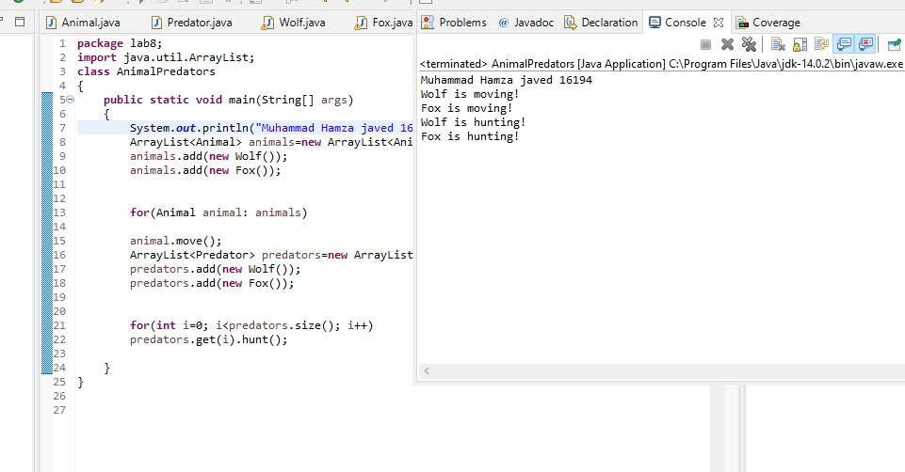

**Lab Assignment:**

1. **Design an interface Crawlable with method crawl. Create another interface Moveable with method move. Then Design a class Animal and implement both interfaces to show multiple inheritance.**

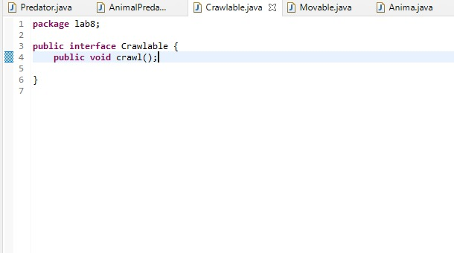

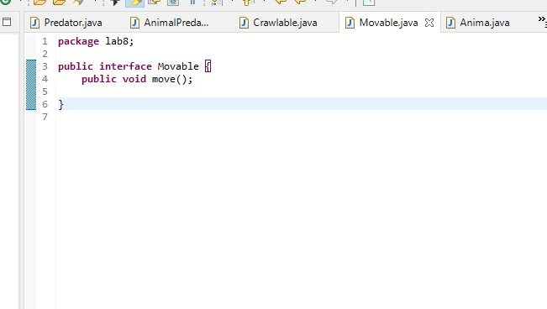

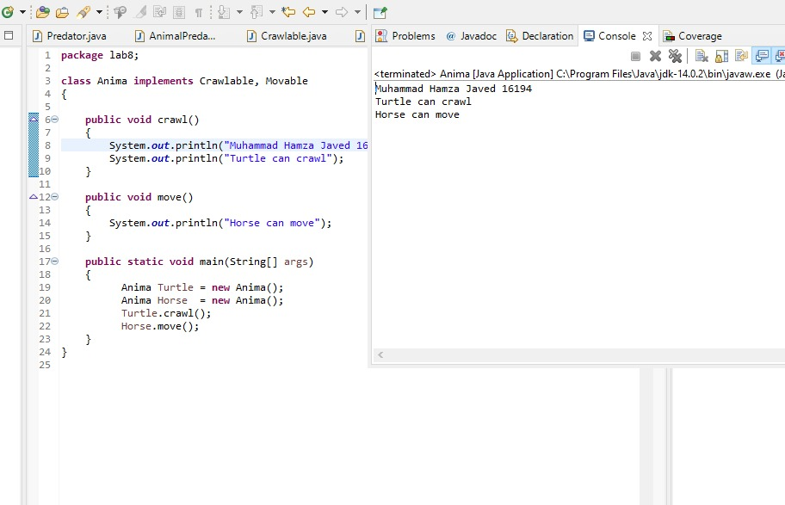

1. **We have to calculate the area of a rectangle, a square and a circle. Create an interface class "Shape" with three methods namely "RectangleArea"; taking two parameters, "SquareArea" and "CircleArea" taking one parameter each. The parameters of "RectangleArea" are its length and breadth, that of "SquareArea" is its side and that of "CircleArea" is its radius. Now create another class "Area" containing all the three methods "RectangleArea", "SquareArea" and "CircleArea" for printing the area of rectangle, square and circle respectively. Create an object of class "Area" and call all the three methods.**

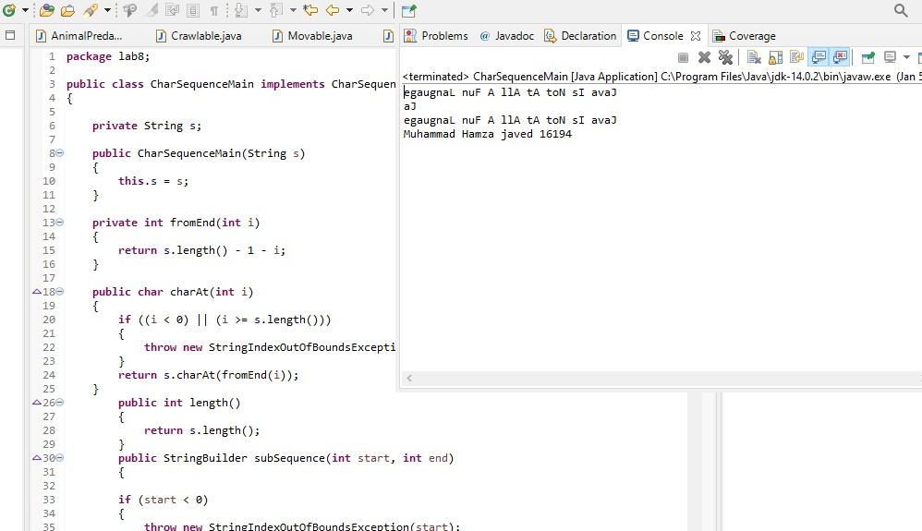

**Conclusion:**

The Concept and Implementation of Interface is the learning outcome of this lab and after this lab we learned it very well.

**Lab-09**

**Introducing JavaFx**

**Objectives:**

Introduction to JavaFx labels and content

**Theory:**

JavaFX is a set of graphics and media packages that enables developers to design, create, test, debug, and deploy rich client applications that operate consistently across diverse platforms.

The applications developed using JavaFX can run on various devices such as Desktop Computers, Mobile Phones, TVs, Tablets, etc.

To develop GUI Applications using Java programming language, the programmers rely on libraries such as Advanced Windowing Tool kit and Swings. After the advent of JavaFX, Java programmers can now develop GUI applications effectively with rich content.

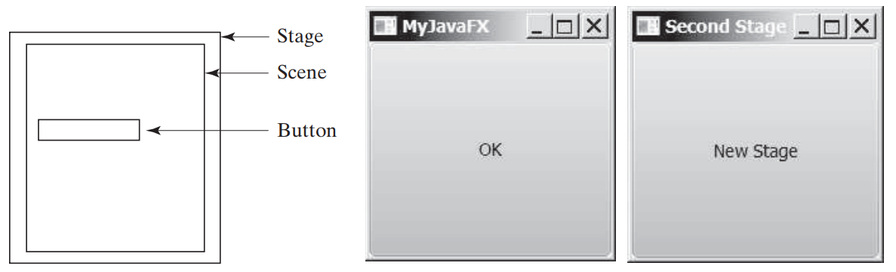

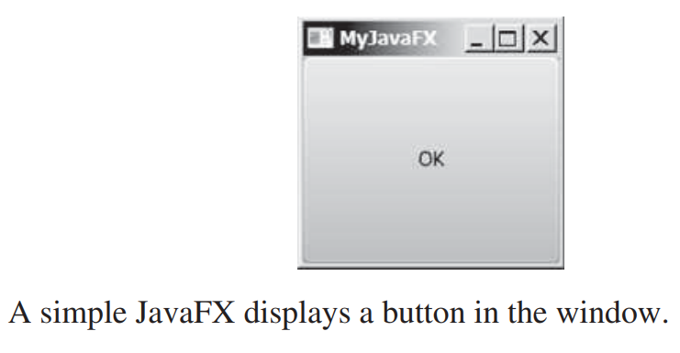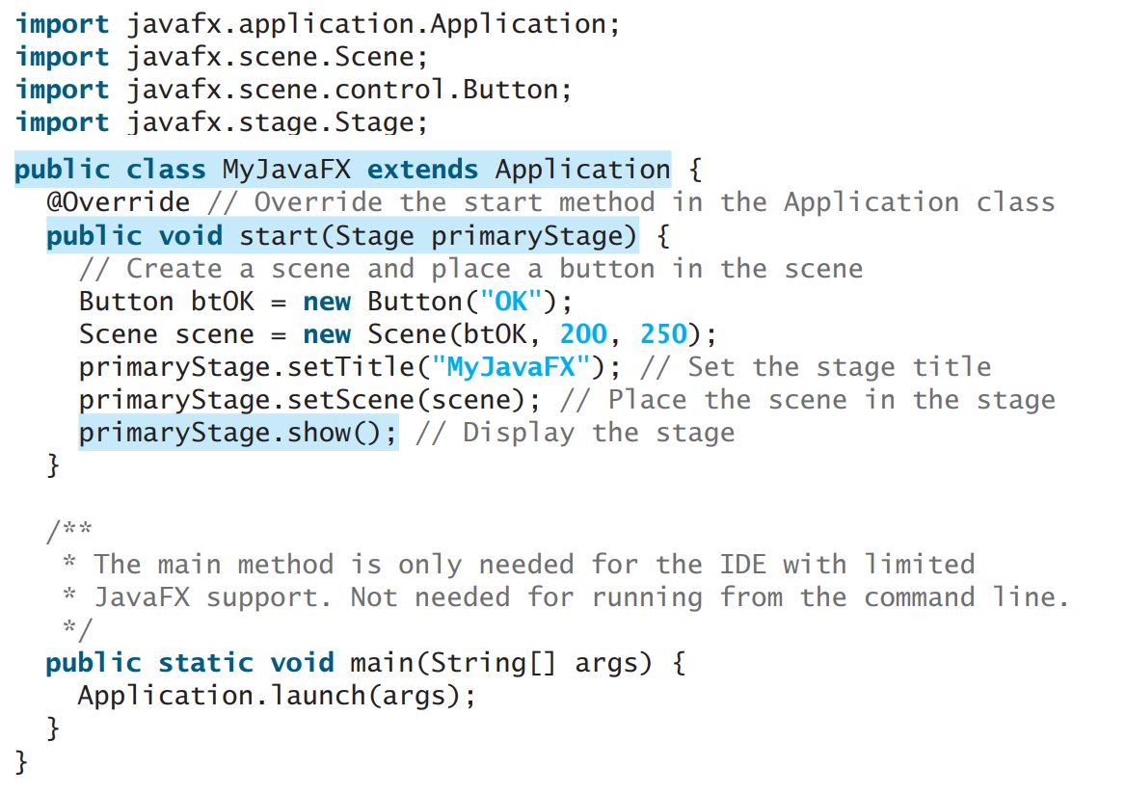

**import** javafx.application.Application;

**import** javafx.scene.Scene;

**import** javafx.scene.control.Button;

**import** javafx.scene.control.Label;

**import** javafx.scene.control.TextField;

**import** javafx.scene.layout.GridPane;

**import** javafx.stage.Stage;

**public** **class** Label_Test **extends** Application {

**public** **void** start(Stage primaryStage) **throws** Exception {

        Label first_name=**new** Label("First Name");

        Label last_name=**new** Label("Last Name");

        TextField tf1=**new** TextField();

        TextField tf2=**new** TextField();

        Button Submit=**new** Button ("Submit");

        GridPane root=**new** GridPane();

        Scene scene = **new** Scene(root,400,200);

        root.addRow(0, first_name,tf1);

        root.addRow(1, last_name,tf2);

        root.addRow(2, Submit);

        primaryStage.setScene(scene);

        primaryStage.show();

    }

**public** **static** **void** main(String[] args) {

        Application.launch(args);

    }

}

**Lab Task:**

**Execute the program and paste the output.**

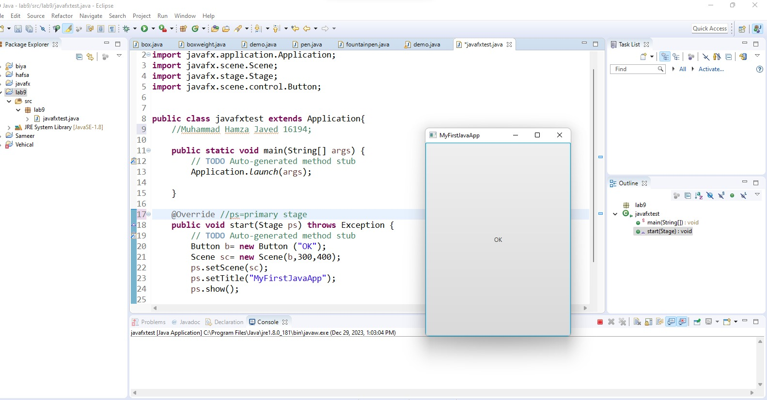

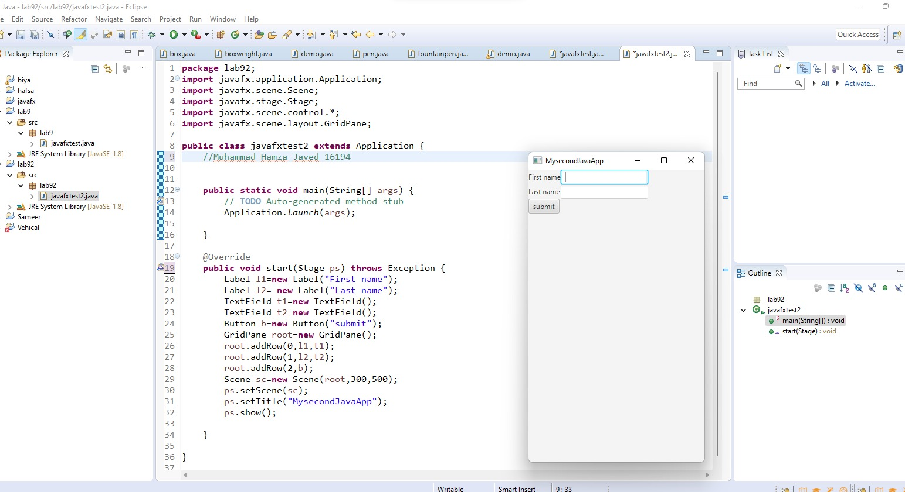

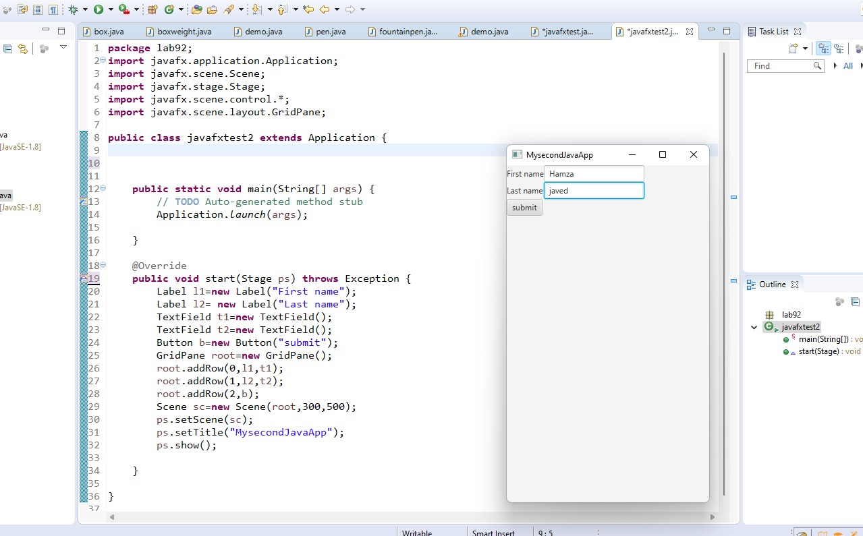

**Conclusion:This lab allow us to understand the basics of GUI by using JavaFX**

**Lab-10**

**Exploring JavaFx**

**Objectives:**

Show different JavaFx Layouts and Charts.

**Theory:**

**JavaFx Layouts**

Layouts are the top level container classes that define the UI styles for scene graph objects. In JavaFX, Layout defines the way in which the components are to be seen on the stage. It basically organizes the scene-graph nodes. We have several built-in layout panes in JavaFX that are HBox, VBox, StackPane, FlowBox, AnchorPane, etc. Each Built-in layout is represented by a separate class which needs to be instantiated in order to implement that particular layout pane.

All these classes belong to **javafx.scene.layout** package. **javafx.scene.layout.Pane** class is the base class for all the built-in layout classes in JavaFX.

|  |  |
| --- | --- |
| **Class** | **Description** |
| BorderPane | Organizes nodes in top, left, right, centre and the bottom of the screen. |
| FlowPane | Organizes the nodes in the horizontal rows according to the available horizontal spaces. Wraps the nodes to the next line if the horizontal space is less than the total width of the nodes |
| GridPane | Organizes the nodes in the form of rows and columns. |
| HBox | Organizes the nodes in a single row. |
| Pane | It is the base class for all the layout classes. |
| StackPane | Organizes nodes in the form of a stack i.e. one onto another |
| VBox | Organizes nodes in a vertical column. |

**FlowPane**

import javafx.application.Application;

import javafx.scene.Scene;

import javafx.scene.control.Button;

import javafx.scene.layout.FlowPane;

import javafx.stage.Stage;

public class FlowPaneExperiments extends Application {

@Override

public void start(Stage primaryStage) throws Exception {

primaryStage.setTitle("FlowPane Experimwnt");

Button button1 = new Button("Button Number 1");

Button button2 = new Button("Button Number 2");

Button button3 = new Button("Button Number 3");

FlowPane flowpane = new FlowPane();

flowpane.getChildren().add(button1);

flowpane.getChildren().add(button2);

flowpane.getChildren().add(button3);

Scene scene = new Scene(flowpane, 200, 100);

primaryStage.setScene(scene);

primaryStage.show();

}

public static void main(String[] args) {

Application.launch(args);

}

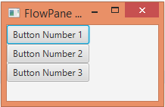}

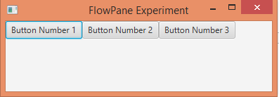

**BorderPane**

package application;

import javafx.application.Application;

import javafx.scene.Scene;

import javafx.scene.control.Label;

import javafx.scene.layout.*;

import javafx.stage.Stage;

public class Label_Test extends Application {

    @Override

    public void start(Stage primaryStage) throws Exception {

        BorderPane BPane = new BorderPane();

        BPane.setTop(new Label("This will be at the top"));

        BPane.setLeft(new Label("This will be at the left"));

        BPane.setRight(new Label("This will be at the Right"));

        BPane.setCenter(new Label("This will be at the Centre"));

        BPane.setBottom(new Label("This will be at the bottom"));

        Scene scene = new Scene(BPane,600,400);

        primaryStage.setScene(scene);

        primaryStage.show();

    }

    public static void main(String[] args) {

        launch(args);

    }

}

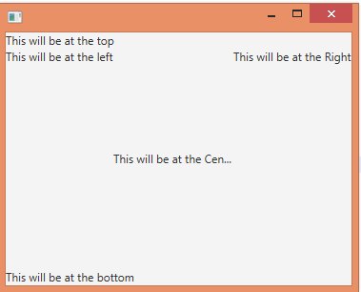

**GridPane**

import javafx.application.Application;

import javafx.scene.Scene;

import javafx.scene.control.Button;

import javafx.scene.layout.GridPane;

import javafx.stage.Stage;

public class GridPaneExperiments extends Application {

@Override

public void start(Stage primaryStage) throws Exception {

primaryStage.setTitle("GridPane Experiment");

Button button1 = new Button("Button 1");

Button button2 = new Button("Button 2");

Button button3 = new Button("Button 3");

Button button4 = new Button("Button 4");

Button button5 = new Button("Button 5");

Button button6 = new Button("Button 6");

GridPane gridPane = new GridPane();

gridPane.add(button1, 0, 0);

gridPane.add(button2, 1, 0);

gridPane.add(button3, 2, 0);

gridPane.add(button4, 0, 1);

gridPane.add(button5, 1, 1);

gridPane.add(button6, 2, 1);

Scene scene = new Scene(gridPane, 240, 100);

primaryStage.setScene(scene);

primaryStage.show();

}

public static void main(String[] args) {

Application.launch(args);

}

}

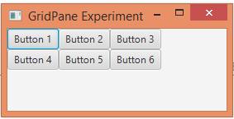

**JavaFx Charts**

In general, a chart is a graphical representation of data. There are various kinds of charts to represent data such as **Bar Chart, Pie Chart, Line Chart, Scatter Chart,** etc.

JavaFX Provides support for various **Pie Charts** and **XY Charts**. The charts that are represented on an XY–plane include **AreaChart, BarChart, BubbleChart, LineChart, ScatterChart, StackedAreaChart, StackedBarChart,** etc.

Each chart is represented by a class and all these charts belongs to the package **javafx.scene.chart**. The class named **Chart** is the base class of all the charts in JavaFX and the **XYChart** is base class of all those charts that are drawn on the XY–plane.

**// Code for Pie Chart**

import javafx.application.Application;

import javafx.scene.Scene;

import javafx.scene.chart.PieChart;

import javafx.scene.layout.VBox;

import javafx.stage.Stage;

public class PieChartExperiments extends Application {

@Override

public void start(Stage primaryStage) throws Exception {

primaryStage.setTitle("My First JavaFX App");

PieChart pieChart = new PieChart();

PieChart.Data slice1 = new PieChart.Data("Desktop", 213);

PieChart.Data slice2 = new PieChart.Data("Phone" , 67);

PieChart.Data slice3 = new PieChart.Data("Tablet" , 36);

pieChart.getData().add(slice1);

pieChart.getData().add(slice2);

pieChart.getData().add(slice3);

VBox vbox = new VBox(pieChart);

Scene scene = new Scene(vbox, 400, 200);

primaryStage.setScene(scene);

primaryStage.setHeight(300);

primaryStage.setWidth(500);

primaryStage.show();

}

public static void main(String[] args) {

Application.launch(args);

}

}

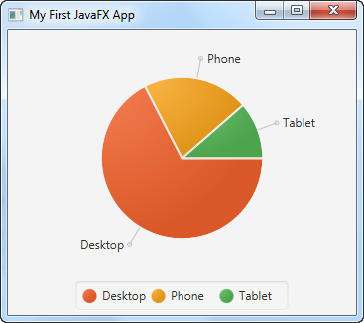

**Lab Task:**

**Rewrite all programs**

* **place your name in the labels in Border pane**
* **place your name in buttons of Flowpane**
* **place your name in buttons in Gridpane**
* **place your name and your friends name in each slice of PieChart**

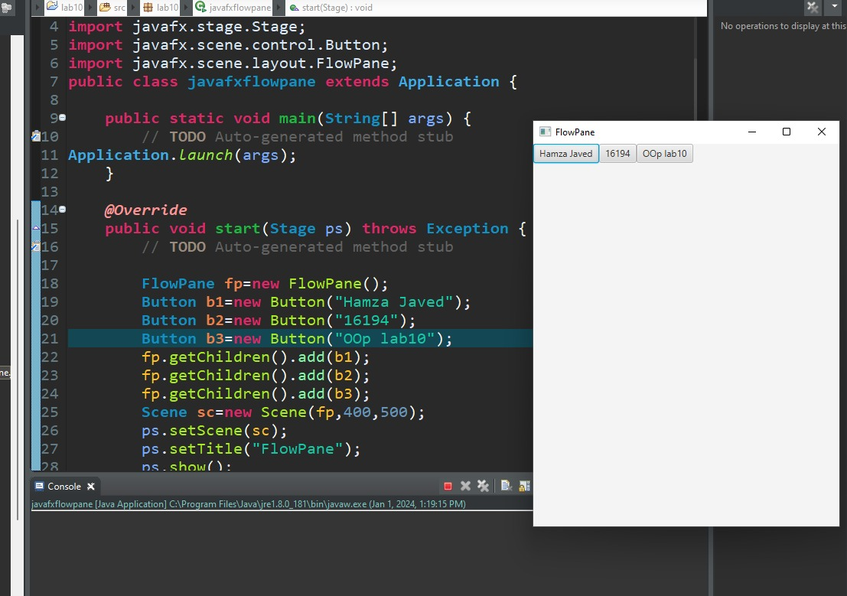

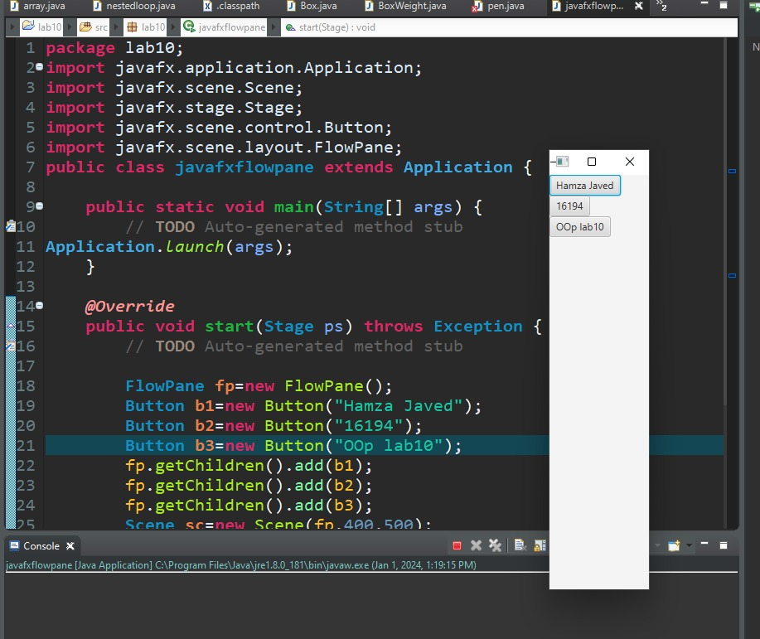

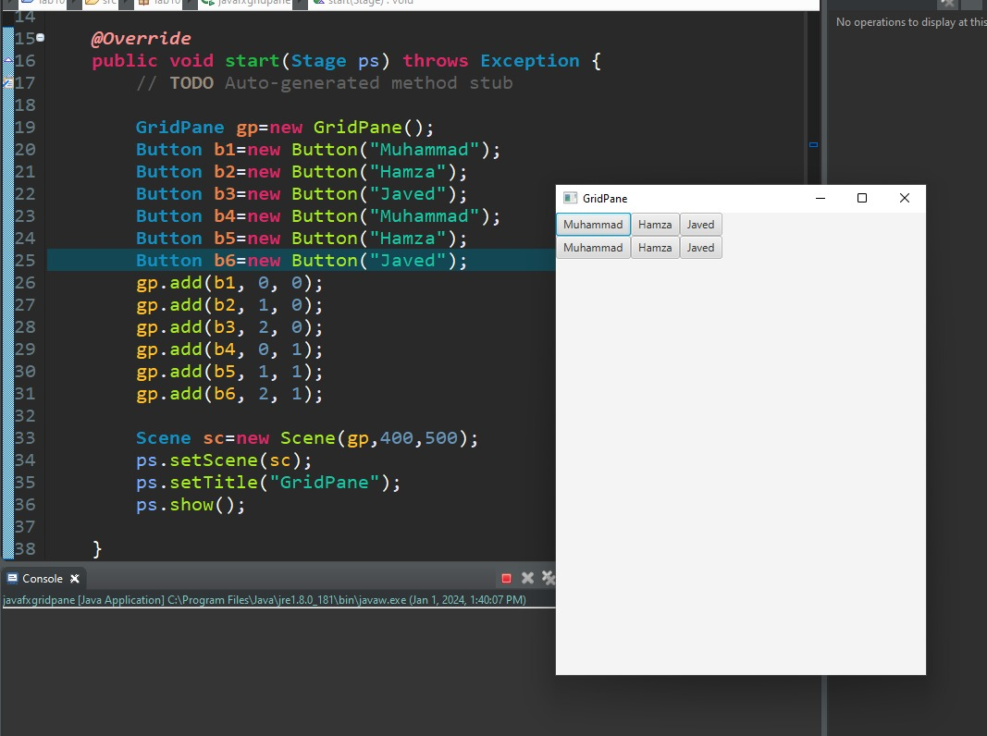

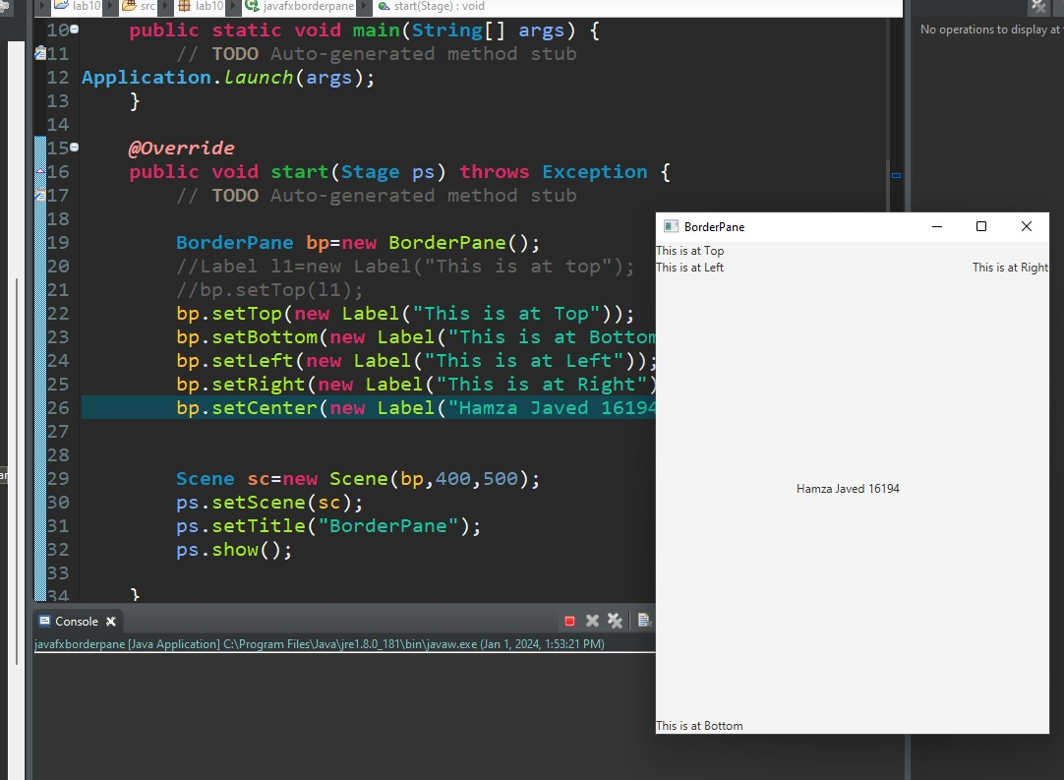

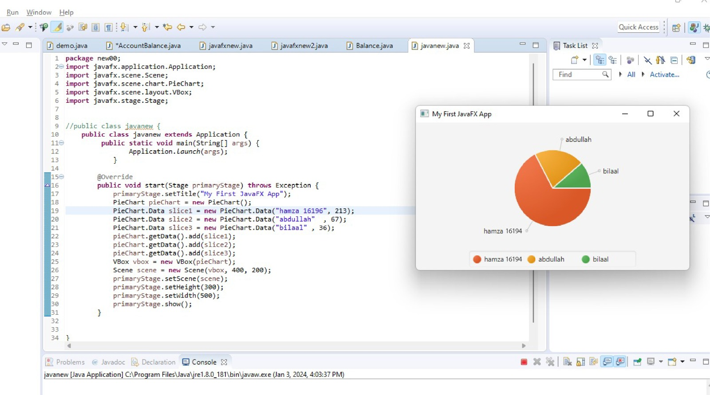

**Conclusion:**

**This lab allow us to understand the basics of GUI by using JavaFX.**

**LAB#11**

**Exception Handling**

**Objective:**

### Understand how runtime errors are being handled in Java.

**Theory:**

An exception is an abnormal condition that arises in a code sequence at run time. In other words, an exception is a run-time error. In computer languages that do not support exception handling, errors must be checked and handled manually—typically through the use of error codes, and so on. This approach is as cumbersome as it is troublesome. Java’s exception handling avoids these problems and, in the process, brings run-time error management into the object oriented world.

A Java exception is an object that describes an exceptional (that is, error) condition that has occurred in a piece of code. When an exceptional condition arises, an object representing that exception is created and thrown in the method that caused the error. That method may choose to handle the exception itself, or pass it on. Either way, at some point, the exception is caught and processed.

Java exception handling is managed via five keywords: *try, catch, throw, throws*, and *finally*.

**Lab Task:**

To guard against and handle a run-time error, simply enclose the code that you want to monitor inside a try block. Immediately following the try block, includes a catch clause that specifies the exception type that you wish to catch. To illustrate how easily this can be done, the following program includes a try block and a catch clause that processes the ArithmeticException generated by the division-by-zero error:

class ExceptionHandling {

public static void main(String args[]) {

int d, a;

**try**

{ // monitor a block of code.

d = 0;

a = 42 / d;

System.out.println("This will not be printed.");

}

**catch** (ArithmeticException e)

{ // catch divide-by-zero error

System.out.println("Division by zero. " + e);

}

**finally** {

System.out.println("finally");

}

System.out.println("After catch statement.");

}

}

Here is a sample program that creates and throws an exception. The handler that catches the exception rethrows it to the outer handler.

// Demonstrate throw.

class ThrowDemo {

static void demoproc() {

try {

**throw** new NullPointerException("demo");

} catch(NullPointerException e) {

System.out.println("Caught inside demoproc.");

**throw** e; // rethrow the exception

}

}

public static void main(String args[]) {

try {

demoproc();

} catch(NullPointerException e) {

System.out.println("Recaught: " + e);

}

}

}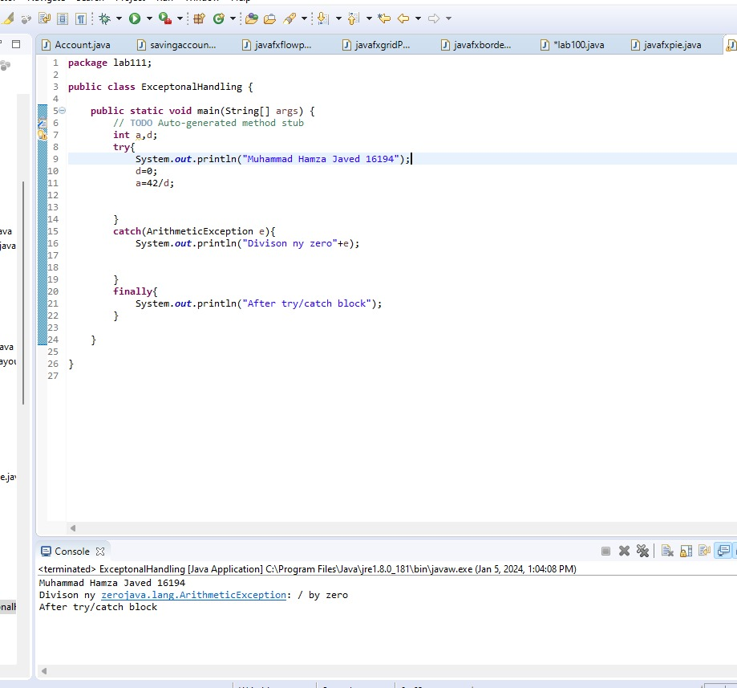

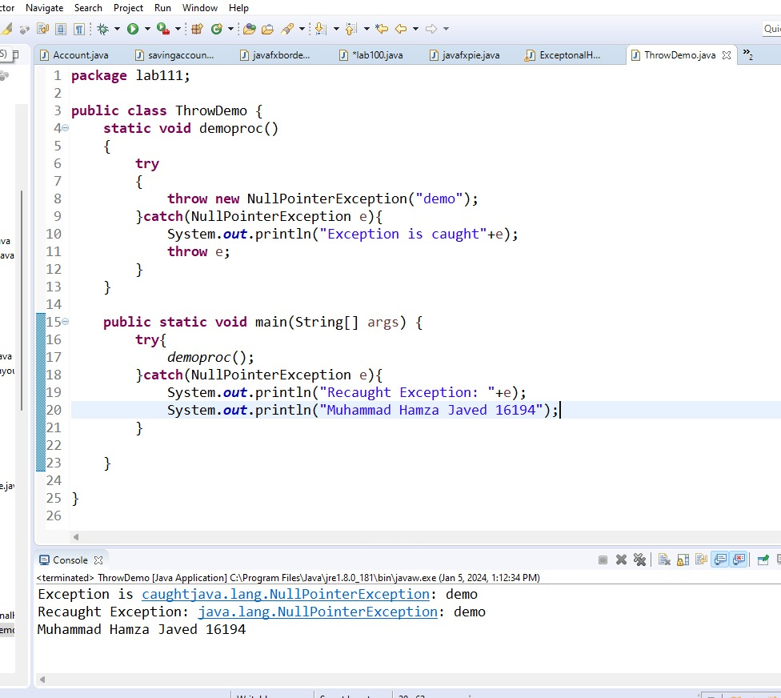

**Lab Task:**

import java.util.regex.Matcher;

import java.util.regex.Pattern;

import java.util.Scanner;

public class ValidateCNIC {

public void method() {

String CNIC;// = "42101-1234567-2";

Scanner sc= new Scanner(System.*in);*

System.*out.println("Enter CNIC in the following pattern XXXXX-XXXXXXX-X");*

CNIC=sc.next();

Pattern pattern = Pattern.*compile("\\d{5}-\\d{7}-\\d{1}");*

Matcher matcher = pattern.matcher(CNIC);

try

{if (matcher.matches())

System.*out.println("CNIC Valid");*

else throw new InvalidCNICException("The CNIC you Entered is not valid");

}

catch(InvalidCNICException e) {

System.*out.println("The CNIC you Entered is not valid");*

}

}

public static void main(String[] args) {

ValidateCNIC test = new ValidateCNIC();

test.method();

}

}

public class InvalidCNICException extends Exception{

public InvalidCNICException() {}

InvalidCNICException(String s){ super(s);}}

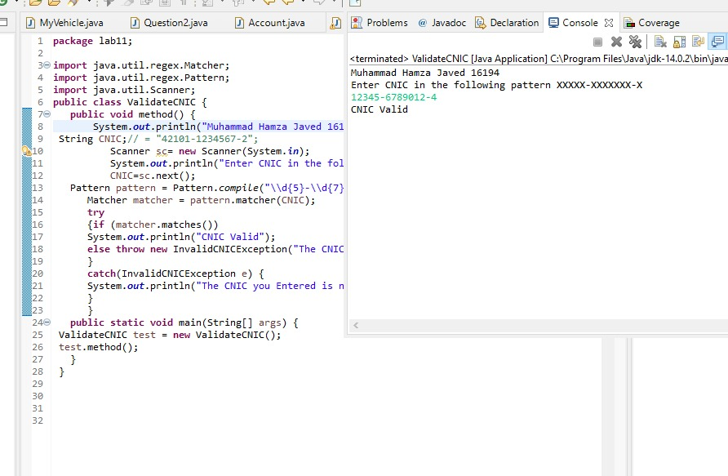

**Lab Assignment:**

1. **Design a program to implement calculator’s basic functionality with an exception handler that deals with nonnumeric operands; then Design another program without using an exception handler to achieve the same objective. Your program should display a message that informs the user of the wrong operand type before exiting.**

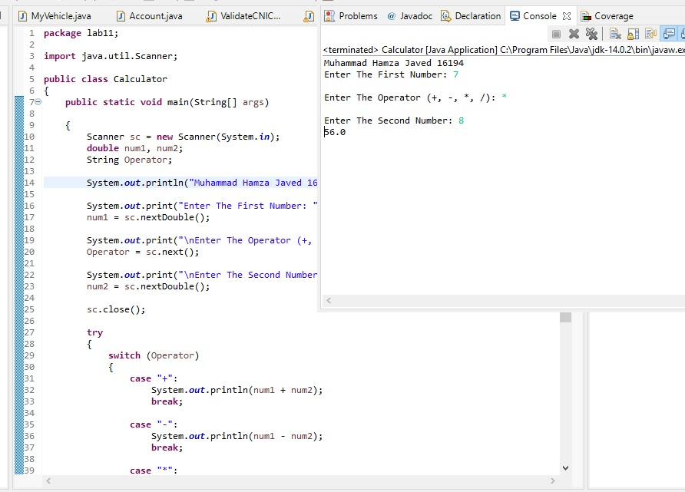

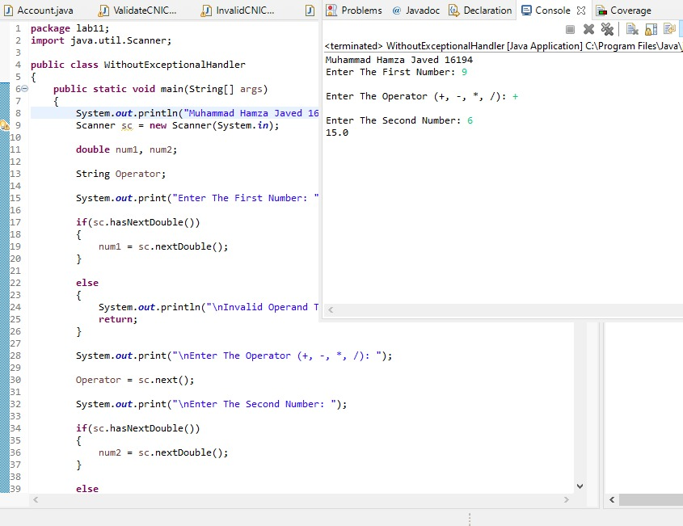

1. **Write a Java program to create a method that takes a string as input and throws an exception if the string does not contain vowels.**

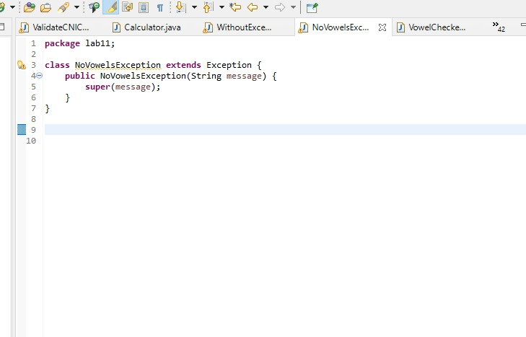

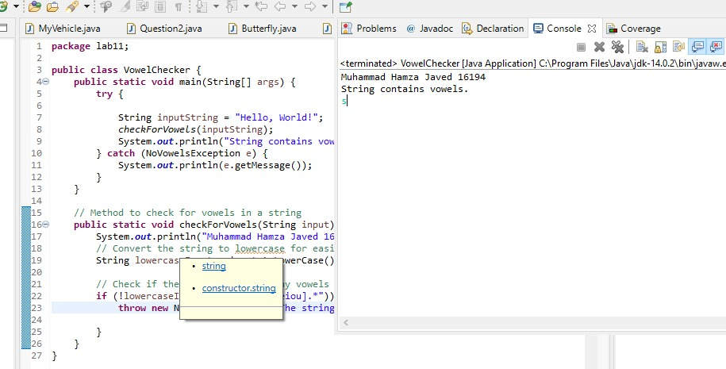

**Conclusion:** In this lab we learn about how to do exceptional handling try catch etc.